

**Requirement & Design Specification**

**Lux Furniture**

**Version: 1.0**

– Ho Chi Minh, March 2024 –

# I. Overview

## 1. User Requirements

### 1.1 Actors

|  |  |  |
| --- | --- | --- |
| **#** | **Actor** | **Description** |
| 1 | Admin | - Is notified when critical system events occur, such as low inventory levels, high traffic, or security breaches.  - Provides information such as product updates, pricing changes, and promotional offers to the system.  - Helps the system respond to tasks related to managing users, products, orders, and overall system configuration. |
| 2 | Staff | - Is notified about new orders, customer inquiries, or any issues related to products or services.  - Provides information such as product availability, order status, and customer support to the system.  - Helps the system respond to tasks related to order processing, customer assistance, and inventory management. |
| 3 | Customer | - Is notified about order confirmations, shipping updates, and any changes to their account or orders.  - Provides information such as personal details, shipping addresses, and payment methods to the system.  - Helps the system respond to tasks related to browsing products, placing orders, and managing their account. |
| 4 | Registered User | - May receive notifications regarding account-related activities such as password changes, subscription updates, or account verification.  - Provides information such as preferences, saved items, and past orders to the system.  - Helps the system respond to tasks related to personalized recommendations, account management, and loyalty programs. |
| 5 | Guest | - May not be notified directly, but their actions (such as browsing behavior or cart abandonment) may trigger automated responses or notifications within the system.  - Provides limited information such as browsing history, cart contents, and contact details (if provided during checkout) to the system.  - Helps the system respond to tasks related to guest checkout, product exploration, and potentially converting them into registered users or customers. |

### 1.2 Use Cases

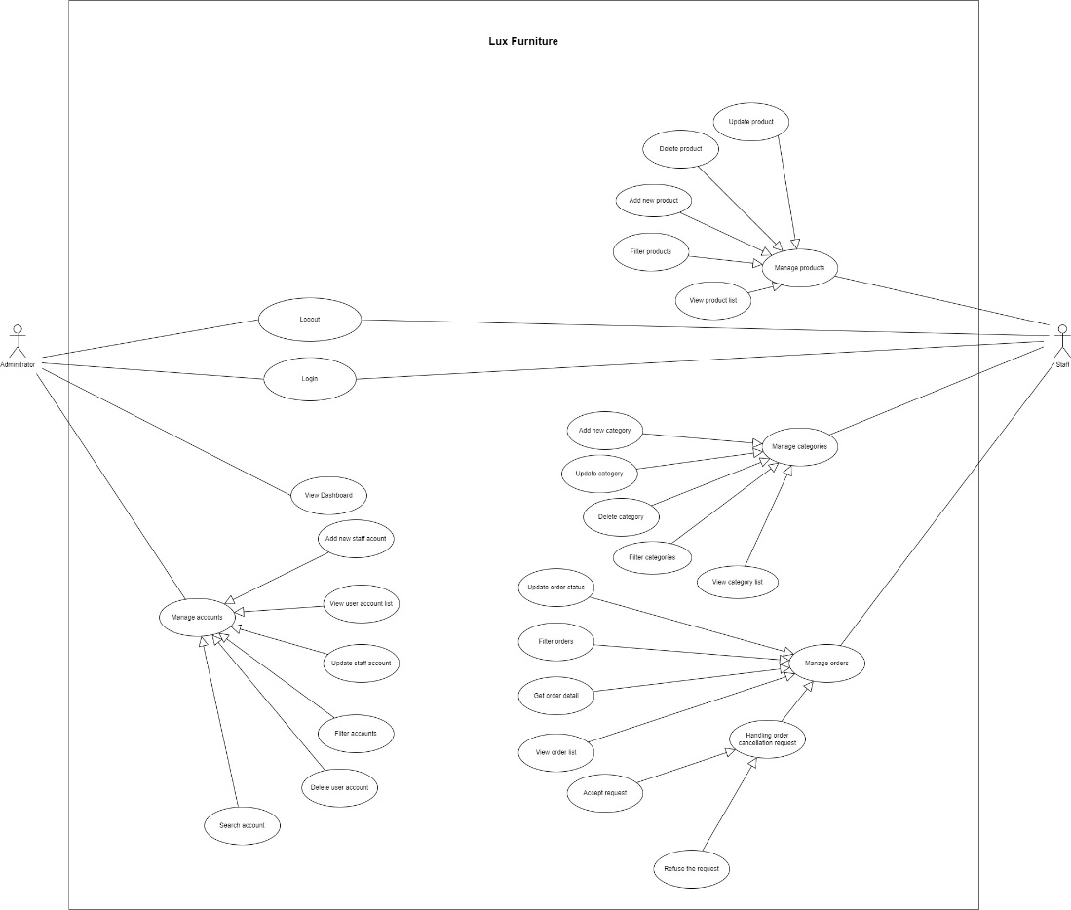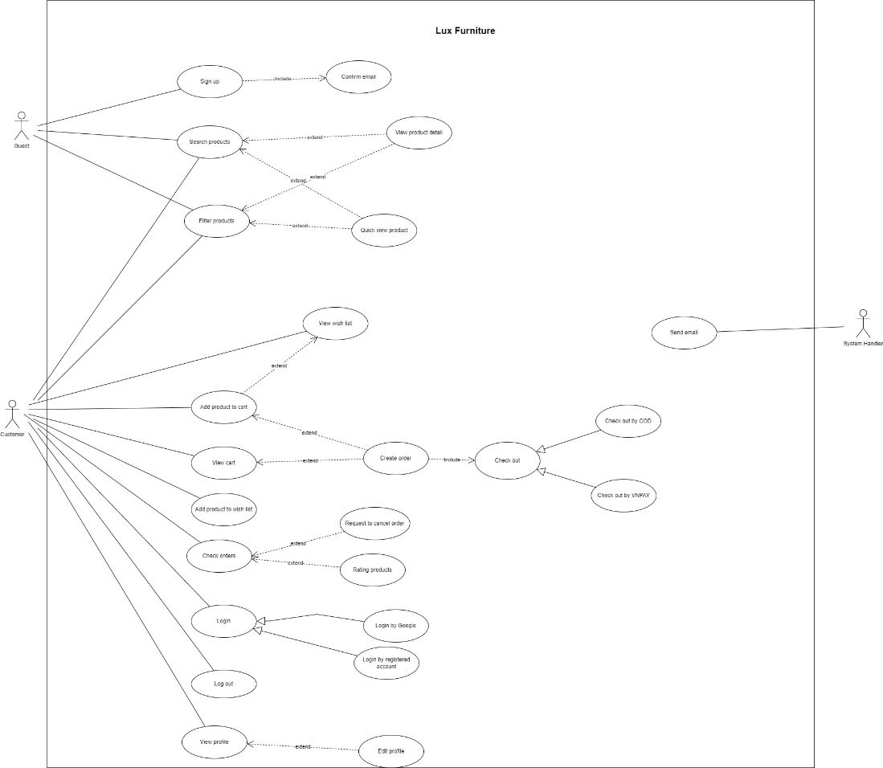

## 2. System High Level Design

### 2.1 Database Design

#### a. Database Schema

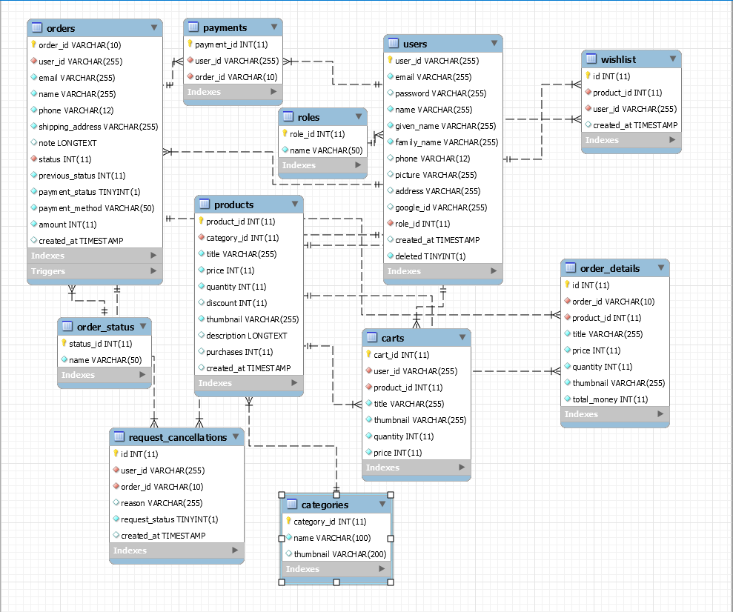

#### b. Table Descriptions

|  |  |  |
| --- | --- | --- |
| **No** | **Table** | **Description** |
| 01 | users | - Primary keys: user_id |
| 02 | roles | - Primary keys: role_id |
| 03 | orders | - Primary keys: order_id  -Foreign keys: user_id |
| 04 | order_details | - Primary keys: id  -Foreign keys: order_id, product_id |
| 05 | order_status | - Primary keys: status_id  -Foreign keys: name |
| 06 | carts | - Primary keys: cart_id  -Foreign keys: user_id |
| 07 | products | - Primary keys: product_id  -Foreign keys: category_id |
| 08 | categories | - Primary keys: category_id |
| 09 | request_cancellations | - Primary keys: id |

# II. Requirement Specifications

## 1. Registered user

### 1.1 UC-1_Login

#### a. Functional Description

|  |  |  |  |
| --- | --- | --- | --- |
| **UC-1_Login** | | | |
| Use-case No. | UC-1 | Use-case Version | 1.0 |
| Use-case Name | Login | | |
| Author | Lê Như Ngọc | | |
| Date | 17/03/2024 | Priority | high |
| **Actor**: Registered User  **Summary**: This use case allows Registered User to log into the system.  **Goal**: Actors can log into their accounts  **Triggers**: The Registered User wants to login.  **Preconditions**: Registered User is logged in to the system.  **Post Conditions**: 1. User logs in the system successfully  2.The system tracked successful login into the Activity Log  **Main Success Scenario:**     |  |  |  | | --- | --- | --- | | No. | Actor Action | System Response | | 1 | Actors click icon to show popup and click “đăng nhập” to login in the system | The system shows the login page for the user to enter specific information:   * Email * Mật khẩu * “Đăng nhập” Button | | 2 | Actors enter your email and mật khẩu, then click "đăng nhập" button to log into the system | The system redirects to the home page |   **Alternative Scenario**: N/A  **Exceptions**:     |  |  |  | | --- | --- | --- | | No. | Cause | System Response | | 1 | There was a problem with user login. | The system shows an error message: "Email hoặc mật khẩu không chính xác" |     **Relationships**:   * **Business Rule**s: FR1, FR2, FR3 | | | |

#### b. Business Rules

|  |  |  |
| --- | --- | --- |
| **ID** | **Business Rule** | **Business Rule Description** |
| FR1 | Password Encoding | User’s password must be encoded with MD5 hashing |
| FR2 | Invalid Logging In | User can’t be authenticated to login the system if below cases   * His/her logging-in details are incorrect * His/her account has not been verified * His/her account has been locked or blocked |
| FR3 | Account Locking | If user inputs wrong logging-in details 6 times continuously, his/her account would be locked in 30 minutes |

### 1.2 UC-2_Login by Google

#### a. Functional Description

|  |  |  |  |
| --- | --- | --- | --- |
| **UC-2_Login by Google** | | | |
| Use-case No. | UC-2 | Use-case Version | 1.0 |
| Use-case Name | Login by Google | | |
| Author | Lê Như Ngọc | | |
| Date | 17/03/2024 | Priority | high |
| **Actor**: Registered User  **Summary**: This use case allows Registered User to log into the system.  **Goal**: Actors can log into their accounts  **Triggers**: The Registered User wants to login by Google.  **Preconditions**: Registered User is logged in to the system.  **Post Conditions**: 1. User logs in the system successfully  2.The system tracked successful login into the Activity Log  **Main Success Scenario:**   |  |  |  | | --- | --- | --- | | No. | Actor Action | System Response | | 1 | Actors click “Google” icon to enter login | The system shows a popup of the user's Google accounts for authentication | | 2 | Actors clicks on Google's account | The system redirects to the home page |   **Alternative Scenario**: N/A  **Exceptions**: N/A  **Relationships**:   * **Business Rule**s: FR1, FR2, FR3 | | | |

#### b. Business Rules

|  |  |  |
| --- | --- | --- |
| **ID** | **Business Rule** | **Business Rule Description** |
| FR1 | Authentication Source | User authentication must be performed through Google's authentication service. |
| FR2 | Authorization Validation | Users must be authorized by Google's service before accessing the system. |
| FR3 | Error Handling | Effective error handling mechanisms must be in place to manage authentication failures from Google's service and provide clear error messages to users. |

### 1.3 UC-3_View Profile

#### a. Functional Description

|  |  |  |  |
| --- | --- | --- | --- |
| **UC-3_View Profile** | | | |
| Use-case No. | UC-3 | Use-case Version | 1.0 |
| Use-case Name | View Profile | | |
| Author | Lê Như Ngọc | | |
| Date | 17/03/2024 | Priority | high |
| **Actor**: Registered User  **Summary**: This use case allows Registered User to view their profile.  **Goal**: Actors can log into their accounts  **Triggers**: The Registered User wants to view profile.  **Preconditions**: Registered User is logged in to the system.  **Post Conditions**: Actor views profile in the system successfully  **Main Success Scenario:**     |  |  |  | | --- | --- | --- | | No. | Actor Action | System Response | | 1 | Actors click “tài khoản” icon to enter login | The system shows the login page for the user to enter specific information:   * Họ và tên * Số điện thoại * Email * Địa chỉ * Ảnh đại diện * Mật khẩu |   **Alternative Scenario**: N/A  **Exceptions**: N/A  **Relationships**:   * **Business Rule**s: FR1, FR2 | | | |

#### b. Business Rules

|  |  |  |
| --- | --- | --- |
| **ID** | **Business Rule** | **Business Rule Description** |
| FR1 | Access Authorization | Users must be logged in to view their profile. |
| FR2 | Profile Privacy | Users can only view their own profile, not profiles of other users. |

### 1.4. UC-4_Edit Profile

#### a. Functional Description

|  |  |  |  |
| --- | --- | --- | --- |
| **UC-4_Edit Profile** | | | |
| Use-case No. | UC-4 | Use-case Version | 1.0 |
| Use-case Name | Edit Profile | | |
| Author | Lê Như Ngọc | | |
| Date | 17/03/2024 | Priority | high |
| **Actor**: Registered User  **Summary**: This use case allows Registered User to log into the system.  **Goal**: Actors can log into their accounts  **Triggers**: The Registered User wants to edit profile.  **Preconditions**: Registered User is logged in to the system.  **Post Conditions**: Actors edit profile in the system successfully  **Main Success Scenario:**     |  |  |  | | --- | --- | --- | | No. | Actor Action | System Response | | 1 | Actors click icon to edit profile | The system shows the account page for the user seen information detail:   * Họ và tên * Số điện thoại * Email * Địa chỉ | | 2 | Actors chooses to edit "Họ và tên" and click “Lưu” button | The system shows the edited information |   **Alternative Scenario**: N/A  **Exceptions**: N/A  **Relationships**:   * **Business Rule**s: FR1, FR2 | | | |

#### b. Business Rules

|  |  |  |
| --- | --- | --- |
| **ID** | **Business Rule** | **Business Rule Description** |
| FR1 | Access Authorization | Users must be logged in to edit their profile. |
| FR2 | Profile Completeness | Users must provide required information when editing their profile. |

### 1.5. UC-5_Logout

#### a. Functional Description

|  |  |  |  |
| --- | --- | --- | --- |
| **UC-5_Logout** | | | |
| Use-case No. | UC-5 | Use-case Version | 1.0 |
| Use-case Name | Logout | | |
| Author | Lê Như Ngọc | | |
| Date | 17/03/2024 | Priority | high |
| **Actor**: Registered User  **Summary**: This use case allows Registered User to log into the system.  **Goal**: Actors can logout in the system  **Triggers**: The Registered user wants to logout of account.  **Preconditions**: Registered User is logged in to the system.  **Post Conditions**: Actors logout in the system successfully  **Main Success Scenario:**     |  |  |  | | --- | --- | --- | | No. | Actor Action | System Response | | 1 | Actors click icon to show popup and click “đăng xuất” to logout of the system | The system will logout of the account and redirect to the home page |   **Alternative Scenario**: N/A  **Exceptions**: N/A  **Relationships**:   * **Business Rule**s: FR1, FR2 | | | |

#### b. Business Rules

|  |  |  |
| --- | --- | --- |
| ID | Business Rule | Business Rule Description |
| FR1 | Session Termination | User's session must be securely terminated upon logout. |
| FR2 | Access Control | After logout, the user should be redirected to the home page. |

## 2. Customer

### 2.1 UC-6_View Wish List

|  |  |  |  |
| --- | --- | --- | --- |
| **USE CASE-01 View Wish List** | | | |
| **Use-case No.** | UC-01 | **Use-case Version** | 1.0 |
| **Use-case Name** | View Wish List | | |
| **Author** | Truong Minh Tien | | |
| **Date** | 17/03/2024 | **Priority** | Medium |
| **Actor:** Customer  **Summary:**  The feature allows actor to view wish list that the user has previously added to the wish list  **Goal:**     Actor can view the products actor have added to your wish list  **Triggers:**   The actor selects the wish list view function on the system  **Preconditions:**   * Actor is logged into system      * Actor added product to the wish list.   **Post Conditions:**   * The system show all the products actor have added to the wish list   **Main Success Scenario:**   |  |  |  | | --- | --- | --- | | **No** | **Actor’s actions** | **System Responses** | | 1 | Actor clicks on the “Yêu thích” on the header bar. | 2. System show all the product actor have added to the wish list.  2.1 Information displayed includes:  -Title: “Danh sách yêu thích của tôi”  - Information of product:  + images product  + name product  + Sale  + Price is on sale  + Discount percentage |   **Alternative Scenario: N/A**  **Exceptions:**   |  |  |  | | --- | --- | --- | | **No** | **Cause** | **System Response** | | 1 | ***There are no products in the wish list*** | There are no products in the wish list because the user has not added this product |     **Relationships:**  **Business Rules:**   • BR-01: Users can only view their own wish list, not the wish lists of other users.   • BR-02: The wish list should display products in the order they were added. | | | |

### 2.2 UC-7 Add product to wish list

|  |  |  |  |
| --- | --- | --- | --- |
| **USE CASE-02 Add Product To Wish List** | | | |
| **Use-case No.** | UC-02 | **Use-case Version** | 1.0 |
| **Use-case Name** | Add product to wish list | | |
| **Author** | Truong Minh Tien | | |
| **Date** | 17/03/2024 | **Priority** | Medium |
| **Actor:** Customer  **Summary:**  The feature allows actor to add product to wish list.  **Goal:**     Actor can add product to wish list.  **Triggers:**   The actor chooses to add product to the wish list  **Preconditions:**   * Actor is logged into system      * Product must be in stock   **Post Conditions:**   * The system will add that product to the wish list   **Main Success Scenario:**   |  |  |  | | --- | --- | --- | | **No** | **Actor’s actions** | **System Responses** | | 1 | Actor click the heart icon on the product card. | System saves the product that the actor just added to the wish list. | |  |  | System shows popup notifying the user that the product has been successfully added. |   **Alternative Scenario: N/A**  **Exceptions:**   |  |  |  | | --- | --- | --- | | **No** | **Cause** | **System Response** | | 1 | ***There are no products in the wish list*** | Actor click the heart button again to remove the product from the wish list |     **Relationships:**  **Business Rules:**   • BR-01: Only logged-in users can add products to the wish list.   • BR-02: Each product can only be added to the wish list once. | | | |

### 2.3 UC-8 Add product to wish cart

|  |  |  |  |
| --- | --- | --- | --- |
| **USE CASE-03 Add Product To Wish Cart** | | | |
| **Use-case No.** | UC-03 | **Use-case Version** | 1.0 |
| **Use-case Name** | Add product to wish cart | | |
| **Author** | Truong Minh Tien | | |
| **Date** | 17/03/2024 | **Priority** | Hight |
| **Actor:** Customer  **Summary:**  The feature allows actor to add product to cart .  **Goal:**     Actor can add product to cart.  **Triggers:**   The actor chooses to add product to the cart  **Preconditions:**   * Actor is logged into system      * Product must be in stock   **Post Conditions:**   * The system will add that product to the cart   **Main Success Scenario:**   |  |  |  | | --- | --- | --- | | **No** | **Actor’s actions** | **System Responses** | | 1 | Actor click the cart icon on the product card. | System saves the product that the actor just added to the cart. | |  |  | System displays a popup notifying the user that the product has been successfully added and show the newly added product. | |  |  | 3.1 Information displayed includes:  - Bạn đã thêm [{product}] vào giỏ hàng  - Giỏ hàng của bạn hiện có n sản phẩm  - Thông tin sản phẩm:  + image  + Đơn giá  + Số lượng  + Thành tiền  + Xoá  + Tổng Tiền  + Thanh Toán |   **Alternative Scenario:**   |  |  |  | | --- | --- | --- | | **No** | **Actor’s actions** | **System Responses** | | 1 | Actor click the product to view product detail | System closes the access granting process and returns to the main menu. | |  | Actor click “Thêm vào giỏ hàng” button. | The system displays a popup notifying the user that the product has been successfully added and show the newly added product. | |  |  | Information displayed includes:  - Bạn đã thêm [{product}] vào giỏ hàng  - Giỏ hàng của bạn hiện có n sản phẩm  - Thông tin sản phẩm:  + image  + Đơn giá  + Số lượng  + Thành tiền  + Xoá  + Tổng Tiền  + Thanh Toán |   **Exceptions:**   |  |  |  | | --- | --- | --- | | **No** | **Cause** | **System Response** | | 1 | ***Product must not be in stock*** | Actor cannot click add to cart with product must not be in stock |     **Relationships:**  **Business Rules:**   • BR-01: When the user enters a certain quantity, a message out of stock will be displayed if there is no more stock in stock.   • BR-02: Require users to select sizes and colors before adding | | | |

### 2.4 UC-9 Add product to wish cart

|  |  |  |  |
| --- | --- | --- | --- |
| **USE CASE-04 View Cart** | | | |
| **Use-case No.** | UC-04 | **Use-case Version** | 1.0 |
| **Use-case Name** | View cart | | |
| **Author** | Truong Minh Tien | | |
| **Date** | 17/03/2024 | **Priority** | Hight |
| **Actor:** Customer  **Summary:**  The feature allows actor to view cart.  **Goal:**     Actor can View products added to cart.  **Triggers:**   The actor chooses to view cart function.  **Preconditions:**   * Actor is logged into system      * Actor added product to the cart.   **Post Conditions:**   * The system will show all products that have been added by the actor before.   **Main Success Scenario:**   |  |  |  | | --- | --- | --- | | **No** | **Actor’s actions** | **System Responses** | | 1 | The actor click the “Giỏ hàng” button on the header bar. | 1. System show all products that have been added by the actor before. | |  |  | 1. System displays a popup notifying the user that the product has been successfully added and show the newly added product. | |  |  | 2.1 Information displayed includes:  - Bạn đã thêm [{product}] vào giỏ hàng  - Giỏ hàng của bạn hiện có n sản phẩm  - Thông tin sản phẩm:  + image  + Đơn giá  + Số lượng  + Thành tiền  + Xoá  + Tổng Tiền  + Thanh Toán |   **Alternative Scenario: N/A**   |  |  |  | | --- | --- | --- | |  |  |  |   **Exceptions:**   |  |  |  | | --- | --- | --- | | **No** | **Cause** | **System Response** | | 1 | *There are no products in the cart* | The system show a message that there are no products in the shopping cart |     **Relationships:**  **Business Rules:**   • BR-01: Users must log in to view the shopping cart.   • BR-02: Show a message if there are no products in the cart . | | | |

### 2.5 UC-10 Create Order

|  |  |  |  |
| --- | --- | --- | --- |
| **USE CASE-05 Create Order** | | | |
| **Use-case No.** | UC-5 | **Use-case Version** | 1.0 |
| **Use-case Name** | Create Order | | |
| **Author** | Truong Minh Tien | | |
| **Date** | 17/03/2024 | **Priority** | Hight |
| **Actor:** Customer  **Summary:**  The feature allows actor to create order .  **Goal:**    Actor can create orders to pay and buy products.  **Triggers:**   The actor chooses to view cart function.  **Preconditions:**   * Actor is logged into system * Actor added product to the cart. * Product must be in stock   **Post Conditions:**   * The system will create an order and then save it to the database.   **Main Success Scenario:**   |  |  |  | | --- | --- | --- | | **No** | **Actor’s actions** | **System Responses** | | 1 | Actor click the “Thanh toán ” | The system redirects to the order creation page |      |  |  |  | | --- | --- | --- | | 2 | Actor fills in all fields to create order. | The page includes information and fields to fill out.  * Left: - Thông tin nhận hàng: + Email + Họ và tên + Số điện thoại (tuỳ chọn) + Địa chỉ (tuỳ chọn) + Tỉnh thành (tuỳ chọn) + Quận, huyện (tuỳ chọn) + Phường, xã (tuỳ chọn)+ Ghi chú (tuỳ chọn) - Vận Chuyển + Shop shipping amount - Thanh Toán  + Thu Hộ (COD) + Chuyển Khoản  * Right:  - Đơn Hàng (số sản phẩm) - Mã giảm giá - Tạm Tính - Phí vận chuyển - Tổng Cộng - Đặt Hàng button - Quay về giỏ hàng | | 3 | Actor click “Đặt Hàng” button | The system sends an order confirmation notification to the user's gmail  The system redirects to the successful order notification page and displays detailed information about the order just placed | |  |  |  |   **Alternative Scenario: N/A**  **Exceptions:**   |  |  |  | | --- | --- | --- | | **No** | **Cause** | **System Response** | | 1 | *There are no products in the cart* | The system show a message that there are no products in the shopping cart |     **Relationships:**  **Business Rules:**   • BR-01: Confirm valid customer information   • BR-02: Choose from a variety of payment methods and shipping units | | | |

### 2.6 UC-11 Check out

|  |  |  |  |
| --- | --- | --- | --- |
| **USE CASE-06 CHECK OUT** | | | |
| **Use-case No.** | UC-06 | **Use-case Version** | 1.0 |
| **Use-case Name** | Check Out | | |
| **Author** | Truong Minh Tien | | |
| **Date** | 17/03/2024 | **Priority** | Hight |
| **Actor:** Customer  **Summary:**  The feature allows actor to pay for the order.  **Goal:**     Actor can pay for the order.  **Triggers:**   The actor chooses to check out feature.  **Preconditions:**   * Actor is logged into system * Product must be in stock * The order has been created successfully.   **Post Conditions:**   * The system confirmed and recorded in the payment database.   **Main Success Scenario:**   |  |  |  | | --- | --- | --- | | **No** | **Actor’s actions** | **System Responses** | | 1 | Actor click “Thanh Toán” button. | The system redirects to the order creation page | | 2 | Actor fills in all fields to create order.  In the payment section, select “Thu hộ (COD)” | The system sends an order confirmation notification to the user's gmail  The system redirects to the successful order notification page and displays detailed information about the order just placed |   **Alternative Scenario: N/A**   |  |  |  | | --- | --- | --- | |  | Actor click “Thanh Toán” button. | The system redirects to the order creation page | |  | Actor fills in all fields to create order.  In the payment section, select “Thanh toán VNPAY” | The System redirects to the payment page using VNPAY | |  | Actor fills in all information and takes steps to pay with vnpay | The system sends an order confirmation notification to the user's gmail  The system redirects to the successful order notification page and displays detailed information about the order just placed |     **Exceptions:**   |  |  |  | | --- | --- | --- | | **No** | **Cause** | **System Response** | | 1 | Invalid payment information | The system displays an error message. |     **Relationships:**  **Business Rules:**    BR-01: Make sure your order has been confirmed before proceeding to payment.   BR-02: Calculate shipping costs and other incurred taxes for the order.  BR-03: Apply discounts or offers customers may have, like discount codes or promotions. | | | |

### 2.7 UC-12 Check Order

|  |  |  |  |
| --- | --- | --- | --- |
| **USE CASE-07 Check Order** | | | |
| **Use-case No.** | UC-07 | **Use-case Version** | 1.0 |
| **Use-case Name** | Check Order | | |
| **Author** | Truong Minh Tien | | |
| **Date** | 17/03/2024 | **Priority** | Hight |
| **Actor:** Customer  **Summary:**  The feature allows the actor to check order has been paid.  **Goal:**    Actor can check orders to avoid errors and track orders.  **Triggers:**   The actor chooses to check the order function.  **Preconditions:**   * Actor is logged into system * The order has been created and paid for successfully.   **Post Conditions:**   * The system will display details about the orders that have been created.   **Main Success Scenario:**   |  |  |  | | --- | --- | --- | | **No** | **Actor’s actions** | **System Responses** | | 1 | Actors click “Kiểm tra đơn hàng” button. | The system redirects to the check order creation.  A form asking the user to enter information to check appears | | 2 | Actor fills in all fields to check order. | Form information included: - Title: Kiểm tra đơn hàng của bạn - Kiểm tra bằng:  + Số điện thoại + Email | | 2 | Actors click “Kiểm tra” | The page includes information: + Mã đơn hàng:  + Họ và tên khách hàng + Số điện thoại + Email + Ngày mua + Địa chỉ giao hàng +Trạng thái thanh toán  + Trạng thái giao hàng + Giá trị đơn hàng  + Số lượng sản phẩm |   **Alternative Scenario: N/A**  **Exceptions:**   |  |  |  | | --- | --- | --- | | **No** | **Cause** | **System Response** | | 1 | *Order does not exist* | The system will notify an error and ask the customer to check the order information again. |     **Relationships:**  **Business Rules:**   • BR-01: The order must exist in the system   • BR-02: The system needs to confirm the status of the order, including order, processing, shipping, and fulfillment status. | | | |

### 2.8 UC-13 Request to cancel order

|  |  |  |  |  |  |  |  |  |  |  |  |  |  |  |  |  |  |  |  |  |  |  |  |  |  |  |  |  |  |  |  |  |  |  |  |  |  |  |  |  |  |  |  |  |  |  |  |
| --- | --- | --- | --- | --- | --- | --- | --- | --- | --- | --- | --- | --- | --- | --- | --- | --- | --- | --- | --- | --- | --- | --- | --- | --- | --- | --- | --- | --- | --- | --- | --- | --- | --- | --- | --- | --- | --- | --- | --- | --- | --- | --- | --- | --- | --- | --- | --- |
| |  |  |  |  | | --- | --- | --- | --- | | **USE CASE-08 REQUEST TO CANCEL ORDER** | | | | | **Use-case No.** | UC-08 | **Use-case Version** | 1.0 | | **Use-case Name** | Request to cancel order | | | | **Author** | Truong Minh Tien | | | | **Date** | 17/03/2024 | **Priority** | Hight |   **Actor:** Customer  **Summary:**  The feature allows actors to request to cancel order.  **Goal:**    Actor can send request to cancel order.  **Triggers:**   The actor chooses to send a request to cancel order function.  **Preconditions:**   * Actor is logged into system * The order has been created and paid for successfully.   **Post Conditions:**   * The system will cancel that order for the actor.   **Main Success Scenario:**   |  |  |  | | --- | --- | --- | | **No** | **Actor’s actions** | **System Responses** | | 1 | Actors click “Huỷ đơn hàng ” button. | The system redirects to the cancel order page.  A form asking the user to enter information to check appears | | 2 | Actor fills in all fields to check order. | Form information included: - Title: Chọn lý do huỷ đơn hàng + Thay đổi địa chỉ nhận hàng  + Tìm thấy ưu đãi tốt hơn + Thay đổi ý kiến  + Lý do khác | | 2 | Actors click “Xác nhận huỷ hơn hàng” button | The system will receive a request to cancel the order and then it will be sent to the admin and the admin will decide whether to cancel the order or not. | |  |  | Missing “Huỷ đơn hàng” button on order. |   **Alternative Scenario: N/A**   |  |  |  | | --- | --- | --- | |  |  |  |   **Exceptions:**   |  |  |  | | --- | --- | --- | | **No** | **Cause** | **System Response** | | 1 | The order has been processed or shipped | The system may not be able to cancel the order and needs to notify the user about this., | | 2 | The order cancellation deadline has passed | If a cancellation request is submitted after this deadline, the system may not accept it and notify the user of an error. |     **Relationships:**  **Business Rules:**   • BR-01: Specify a deadline for order cancellations, including the maximum time between when the order is placed and when cancellation can be requested.   • BR-02: Determine the specific method and process that customers need to follow to request order cancellation |

## 3. Guest

### 3.1 UC-14 Sign up

### 3.2 UC-15 Search product

3.3 UC-16 Quick view Product

3.4 UC-17 Filter Products

### 3.5 UC-18 View Product Detail

## 4. Admin

### 4.1 UC-19 View dashboard

|  |  |  |  |  |
| --- | --- | --- | --- | --- |
| **USE CASE-1 SPECIFICATION** | | | | |
| **Use-case No.** | UC001 | **Use-case Version** | | 1.0 |
| **Use-case Name** | View dashboard | | | |
| **Author** | Nguyễn Hoàng Phúc | | | |
| **Date** | 17/03/2024 | **Priority** | High | |
| **Actor:**  Admin  **Summary:**  This use case allows the actor to view the dashboard of the system.  **Goal:**  The actor can view the dashboard to watch the revenue of the store in a time and get the idea for developing.  **Triggers:**  The admin decides to review the performance of the store.  **Preconditions:**  - The admin is logged into the system.  - The system is operational and the dashboard functionality is accessible.  **Post Conditions:**  The administrator has successfully accessed and viewed the information in the dashboard (charts, data).  **Main Success Scenario:**   |  |  |  | | --- | --- | --- | | **Step** | **Actor Action** | **System Response** | | 1 | The actor accesses the path to the login page reserved for administrators  [Exception 1,2] | The system displays a login form including the input boxes "Tài khoản" and "Mật khẩu" and the "Đăng nhập" button. | | 2 | Actor enters the account and password and clicks the “Đăng nhập” button. | The system displays the administrator's home page and a list of:  - Bảng điều khiển  - Quản lý tài khoản  - Tạo nhân viên  - Đăng xuất | | 3 | Actor clicks on "Bảng điều khiển" | The system redirects to the dashboard page and displays the date selection boxes "Từ ngày", "Đến ngày". | | 4 | Actor clicks on the boxes and selects the date one by one. | The system displays a line chart showing the store's revenue over the selected time period |   **Alternative Scenario:**  None.  **Exceptions:**     |  |  |  | | --- | --- | --- | | **No** | **Cause** | **System Response** | | 1 | Actor entered the wrong account | The system redirects back to the login page with the message "Tài khoản không tồn tại trong hệ thống". | | 2 | Actor entered wrong password | The system redirects back to the login page with the message "Mật khẩu không đúng. Mật khẩu phải bao gồm các ký tự đặc biệt, chữ in hoa và độ dài trên 8 ký tự." |   **Relationships:**  - UC-xx : Login  **Business Rules:**  - Only authorized admins are allowed to access the dashboard.  - The data displayed on the dashboard should be regularly updated and accurate to facilitate informed decision-making. | | | | |

### 4.2 UC-20 Add new staff account

|  |  |  |  |  |
| --- | --- | --- | --- | --- |
| **USE CASE-2 SPECIFICATION** | | | | |
| **Use-case No.** | UC002 | **Use-case Version** | | 1.0 |
| **Use-case Name** | Add new staff account | | | |
| **Author** | Nguyễn Hoàng Phúc | | | |
| **Date** | 17/03/2024 | **Priority** | High | |
| **Actor:**  Admin  **Summary:**  This function allows the actor to add a new staff account.  **Goal:**  Actors can easily create a new account for a new employee of the store.  **Triggers:**  When an admin needs to create a new account for an employee in the system.  **Preconditions:**  - The admin is logged into the system.  - Newly hired staff do not have a management account yet.  **Post Conditions:**  Successfully created a new account for a new staff member.  **Main Success Scenario:**   |  |  |  | | --- | --- | --- | | **Step** | **Actor Action** | **System Response** | | 1 | The actor accesses the path to the login page reserved for administrators  [Exception 1,2] | The system displays a login form including the input boxes "Tài khoản" and "Mật khẩu" and the "Đăng nhập" button. | | 2 | Actor enters the account and password and clicks the “Đăng nhập” button. | The system displays the administrator's home page and a list of:  - Bảng điều khiển  - Quản lý tài khoản  - Tạo nhân viên  - Đăng xuất | | 3 | Actor clicks on "Tạo nhân viên" | The system displays a registration form with fields including:  - Email  - Mật khẩu  - Nhập lại mật khẩu  - Số điện thoại  - Địa chỉ  - Ngày tháng năm sinh  - Upload ảnh đại diện  - Vai trò (mặc định là Staff role)  - “Đăng ký” <button>  [Exception 3,4,5] | | 4 | The user clicks on the "Đăng ký" button. | The system redirects to "Tạo nhân viên" and includes the message "Đăng ký thành công". The system updates employee data into the users table in the database. |   **Alternative Scenario:**  None.  **Exceptions:**   |  |  |  | | --- | --- | --- | | **No** | **Cause** | **System Response** | | 1 | Actor entered the wrong account | The system redirects back to the login page with the message "Tài khoản không tồn tại trong hệ thống". | | 2 | Actor entered wrong password | The system redirects back to the login page with the message "Mật khẩu không đúng. Mật khẩu phải bao gồm các ký tự đặc biệt, chữ in hoa và độ dài trên 8 ký tự." | | 3 | The actor re-enters the wrong password | The system displays the message "mật khẩu không trùng khớp". | | 4 | Actor enters a phone number that is not within the range of 9-11 characters and a phone number that includes characters other than numbers | The system displays the message "Số điện thoại bạn đã nhập phải nằm trong khoảng 9-11 kí tự và chỉ bao gồm số". | | 5 | Actor entered the wrong date format in dd/MM/yyyy format | The system displays the message "Ngày tháng năm sinh phải đúng định dạng dd/MM/yyyy". |   **Relationships:**  ***UC-xx : Login***  **Business Rules:**   * Data Validation: Ensure all input data is valid, including email, password, phone number, and date of birth. * Security and Permissions: Only admins can create staff accounts, and the system must enforce role-based permissions. | | | | |

### 4.3 UC-21 View user account list

|  |  |  |  |  |
| --- | --- | --- | --- | --- |
| **USE CASE-1 SPECIFICATION** | | | | |
| **Use-case No.** | UC001 | **Use-case Version** | | 1.0 |
| **Use-case Name** | View user account list | | | |
| **Author** | Nguyễn Hoàng Phúc | | | |
| **Date** | 17/03/2024 | **Priority** | High | |
| **Actor:**  Admin  **Summary:**  The admin can view the list of user accounts registered in the system.  **Goal:**  To allow the admin to access and manage user accounts efficiently.  **Triggers**  The admin initiates the action to view the user account list.  **Preconditions:**   * - The admin must be logged into the system. * - The admin must have appropriate permissions to access the user account list.   **Post Conditions:**   * - The admin successfully views the user account list. * - The admin can perform further actions on the user accounts as needed***.***   **Main Success Scenario:**   |  |  |  | | --- | --- | --- | | **Step** | **Actor Action** | **System Response** | | 1 | The actor accesses the path to the login page reserved for administrators  [Exception 1,2] | The system displays a login form including the input boxes "Tài khoản" and "Mật khẩu" and the "Đăng nhập" button. | | 2 | Actor enters the account and password and clicks the “Đăng nhập” button. | The system displays the administrator's home page and a list of:  - Bảng điều khiển  - Quản lý tài khoản  - Tạo nhân viên  - Đăng xuất | | 3 | Actor clicks on "Quản lý tài khoản" | The system displays a table of account list with fields including:   * Id   - Email  - Tên  - Số điện thoại  - Địa chỉ  - Vai trò (mặc định là Staff role)  - “Xóa” <button>  -“Chi tiết” <button>  [Exception 3,4,5] |   **Alternative Scenario:**  None  **Exceptions:**     |  |  |  | | --- | --- | --- | | **No** | **Cause** | **System Response** | | 1 | Actor entered the wrong account | The system redirects back to the login page with the message "Tài khoản không tồn tại trong hệ thống". | | 2 | Actor entered wrong password | The system redirects back to the login page with the message "Mật khẩu không đúng. Mật khẩu phải bao gồm các ký tự đặc biệt, chữ in hoa và độ dài trên 8 ký tự." |   **Relationships:**  UC-xx: Login  **Business Rules:**   * Only authorized admins can access the user account list. * The user account list should display relevant user information without exposing sensitive data. | | | | |

### 4.4 UC-22 Update staff account

|  |  |  |  |  |
| --- | --- | --- | --- | --- |
| **USE CASE-4 SPECIFICATION** | | | | |
| **Use-case No.** | UC004 | **Use-case Version** | | 1.0 |
| **Use-case Name** | Update staff account | | | |
| **Author** | Nguyễn Hoàng Phúc | | | |
| **Date** | 17/03/2024 | **Priority** | High | |
| **Actor:**  Admin  **Summary:**  This use case involves updating information related to a staff member's account by an admin.  **Goal:**  To allow admins to modify staff account details as necessary to ensure accurate and up-to-date records.  **Triggers**  The admin initiates the action to update a staff account.  **Preconditions:**   * The admin must be logged into the system. * The admin must have appropriate permissions to update staff accounts. * The staff account to be updated must already exist in the system.   **Post Conditions:**   * The staff account information is successfully updated with the changes made by the admin. * The updated staff account details are reflected in the system.   **Main Success Scenario:**     |  |  |  | | --- | --- | --- | | **Step** | **Actor Action** | **System Response** | | 1 | The actor accesses the path to the login page reserved for administrators  [Exception 1,2] | The system displays a login form including the input boxes "Tài khoản" and "Mật khẩu" and the "Đăng nhập" button. | | 2 | Actor enters the account and password and clicks the “Đăng nhập” button. | The system displays the administrator's home page and a list of:  - Bảng điều khiển  - Quản lý tài khoản  - Tạo nhân viên  - Đăng xuất | | 3 | Actor clicks on "Quản lý tài khoản" | The system displays a table of account list with fields including:   * Id   - Email  - Tên  - Số điện thoại  - Địa chỉ  - Vai trò (mặc định là Staff role)  - “Xóa” <button>  -“Chi tiết” <button>  [Exception 3,4,5] | | 4 | Actor clicks on the “Chi tiết” button in the row of the staff whose information the actor wants to change. | The system redirects to the detail page and displays the user's information in text format. | | 5 | The administrator re-enters the user's information in the boxes he wants to change the clicks "Cập nhật". | The system redirects the user details page with new information and the message "Cập nhật thành công". |   **Alternative Scenario:**  ***None.***  **Exceptions:**     |  |  |  | | --- | --- | --- | | **No** | **Cause** | **System Response** | | 1 | Actor entered the wrong account | The system redirects back to the login page with the message "Tài khoản không tồn tại trong hệ thống". | | 2 | Actor entered wrong password | The system redirects back to the login page with the message "Mật khẩu không đúng. Mật khẩu phải bao gồm các ký tự đặc biệt, chữ in hoa và độ dài trên 8 ký tự." |   **Relationships:**   * UC-xx: Login * UC-xx: View detail account   **Business Rules:**   * Only authorized admins can update staff account information. * Updates to staff accounts should be communicated to the relevant staff member if necessary. | | | | |

### 4.5 UC-23 Filter account

|  |  |  |  |  |
| --- | --- | --- | --- | --- |
| **USE CASE-5 SPECIFICATION** | | | | |
| **Use-case No.** | UC005 | **Use-case Version** | | 1.0 |
| **Use-case Name** | Filter account | | | |
| **Author** | Nguyễn Hoàng Phúc | | | |
| **Date** | 17/03/2024 | **Priority** | Medium | |
| **Actor:**  Admin  **Summary:**  This use case involves filtering user accounts based on specified criteria by an admin.  **Goal:**  To enable admins to efficiently locate and manage user accounts by applying filters based on specific attributes.  **Triggers**  The admin initiates the action to filter user accounts.  **Preconditions:**   * The admin must be logged into the system. * The admin must have appropriate permissions to filter user accounts.   **Post Conditions:**   * The user accounts meeting the specified filtering criteria are displayed to the admin. * The admin can further perform actions on the filtered user accounts as needed.   **Main Success Scenario:**     |  |  |  | | --- | --- | --- | | **Step** | **Actor Action** | **System Response** | | 1 | The actor accesses the path to the login page reserved for administrators  [Exception 1,2] | The system displays a login form including the input boxes "Tài khoản" and "Mật khẩu" and the "Đăng nhập" button. | | 2 | Actor enters the account and password and clicks the “Đăng nhập” button. | The system displays the administrator's home page and a list of:  - Bảng điều khiển  - Quản lý tài khoản  - Tạo nhân viên  - Đăng xuất | | 3 | Actor clicks on "Quản lý tài khoản" | The system displays a table of account list with fields including:  {   * Id   - Email  - Tên  - Số điện thoại  - Địa chỉ  - Vai trò (mặc định là Staff role)  - “Xóa” <button>  -“Chi tiết” <button>  }  and  - “Chọn vai trò” <select>  - “Kiểu sắp xếp”<select>  - “Lọc” <button>  - “Tìm kiếm” <form>  - “Tìm” <button> | | 4 | Actor clicks "Chọn vai trò" and selects the role to filter |  | | 5 | Actor clicks on "Kiểu sắp xếp" and selects the arrangement type. |  | | 6 | Actor clicks the "Lọc" button | The system displays a list of registered users according to the selected role and arrangement type. |   **Alternative Scenario:**  None.  **Exceptions:**     |  |  |  | | --- | --- | --- | | **No** | **Cause** | **System Response** | | 1 | Actor entered the wrong account | The system redirects back to the login page with the message "Tài khoản không tồn tại trong hệ thống". | | 2 | Actor entered wrong password | The system redirects back to the login page with the message "Mật khẩu không đúng. Mật khẩu phải bao gồm các ký tự đặc biệt, chữ in hoa và độ dài trên 8 ký tự." |   **Relationships:**  UC-xx: Login  **Business Rules:**  Filtering criteria should be clearly defined and user-friendly for admins to select and apply. | | | | |

### 4.6 UC-24 Filter account

|  |  |  |  |  |
| --- | --- | --- | --- | --- |
| **USE CASE-6 SPECIFICATION** | | | | |
| **Use-case No.** | UC006 | **Use-case Version** | | 1.0 |
| **Use-case Name** | Search account | | | |
| **Author** | Nguyễn Hoàng Phúc | | | |
| **Date** | 17/03/2024 | **Priority** | High | |
| **Actor:**  Admin  **Summary:**  This use case involves searching for a specific user account by an admin.  **Goal:**  To enable admins to quickly locate and access specific user accounts based on search criteria.  **Triggers**  The admin initiates the action to search for a user account.  **Preconditions:**   * The admin must be logged into the system. * The admin must have appropriate permissions to search for user accounts.   **Post Conditions:**   * The user account matching the search criteria is displayed to the admin. * The admin can further perform actions on the searched user account as needed.   **Main Success Scenario:**     |  |  |  | | --- | --- | --- | | **Step** | **Actor Action** | **System Response** | | 1 | The actor accesses the path to the login page reserved for administrators  [Exception 1,2] | The system displays a login form including the input boxes "Tài khoản" and "Mật khẩu" and the "Đăng nhập" button. | | 2 | Actor enters the account and password and clicks the “Đăng nhập” button. | The system displays the administrator's home page and a list of:  - Bảng điều khiển  - Quản lý tài khoản  - Tạo nhân viên  - Đăng xuất | | 3 | Actor clicks on "Quản lý tài khoản" | The system displays a table of account list with fields including:  {   * Id   - Email  - Tên  - Số điện thoại  - Địa chỉ  - Vai trò (mặc định là Staff role)  - “Xóa” <button>  -“Chi tiết” <button>  }  and  - “Chọn vai trò” <select>  - “Kiểu sắp xếp”<select>  - “Lọc” <button>  - “Tìm kiếm” <form>  - “Tìm” <button> | | 4 | Actor clicks on the “Tìm kiếm” form and enters the name of the registered user. | The system returns a list of users whose names have been searched. |   **Alternative Scenario:**  ***None.***  **Exceptions:**     |  |  |  | | --- | --- | --- | | **No** | **Cause** | **System Response** | | 1 | Actor entered the wrong account | The system redirects back to the login page with the message "Tài khoản không tồn tại trong hệ thống". | | 2 | Actor entered wrong password | The system redirects back to the login page with the message "Mật khẩu không đúng. Mật khẩu phải bao gồm các ký tự đặc biệt, chữ in hoa và độ dài trên 8 ký tự." |   **Relationships:**  UC-xx: Login  **Business Rules:**  The search functionality should be efficient, providing real-time results as the admin types in the search criteria. | | | | |

### 4.7 UC-25 Delete account

|  |  |  |  |  |
| --- | --- | --- | --- | --- |
| **USE CASE-1 SPECIFICATION** | | | | |
| **Use-case No.** | UC007 | **Use-case Version** | | 1.0 |
| **Use-case Name** | Delete user account | | | |
| **Author** | Nguyễn Hoàng Phúc | | | |
| **Date** | 17/03/2024 | **Priority** | High | |
| **Actor:**  Admin  **Summary:**  This use case involves the deletion of a user account by an admin.  **Goal:**  To provide admins with the capability to remove user accounts from the system when necessary.  **Triggers**  The admin initiates the action to delete a user account.  **Preconditions:**   * The admin must be logged into the system. * The admin must have appropriate permissions to delete user accounts. * The user account to be deleted must exist in the system.   **Post Conditions:**   * The user account is successfully deleted from the system. * Any associated data or records linked to the deleted user account are appropriately handled (e.g., archived or removed) but data of the user still be in the database.   **Main Success Scenario:**     |  |  |  | | --- | --- | --- | | **Step** | **Actor Action** | **System Response** | | 1 | The actor accesses the path to the login page reserved for administrators  [Exception 1,2] | The system displays a login form including the input boxes "Tài khoản" and "Mật khẩu" and the "Đăng nhập" button. | | 2 | Actor enters the account and password and clicks the “Đăng nhập” button. | The system displays the administrator's home page and a list of:  - Bảng điều khiển  - Quản lý tài khoản  - Tạo nhân viên  - Đăng xuất | | 3 | Actor clicks on "Quản lý tài khoản" | The system displays a table of account list with fields including:  {   * Id   - Email  - Tên  - Số điện thoại  - Địa chỉ  - Vai trò (mặc định là Staff role)  - “Xóa” <button>  -“Chi tiết” <button>  }  and  - “Chọn vai trò” <select>  - “Kiểu sắp xếp”<select>  - “Lọc” <button>  - “Tìm kiếm” <form>  - “Tìm” <button> | | 4 | Actor clicks on the “Xóa” . | The system displays the message "Are you sure you want to delete this registered user?" | | 5 | Actor agrees to delete the user account. | The system hides the deleted user account from the table and includes the message "Delete user + <username> successfully". |   **Alternative Scenario:**     |  |  |  | | --- | --- | --- | | **Step** | **Actor Action** | **System Response** | | 1 | The actor accesses the path to the login page reserved for administrators  [Exception 1,2] | The system displays a login form including the input boxes "Tài khoản" and "Mật khẩu" and the "Đăng nhập" button. | | 2 | Actor enters the account and password and clicks the “Đăng nhập” button. | The system displays the administrator's home page and a list of:  - Bảng điều khiển  - Quản lý tài khoản  - Tạo nhân viên  - Đăng xuất | | 3 | Actor clicks on "Quản lý tài khoản" | The system displays a table of account list with fields including:  {   * Id   - Email  - Tên  - Số điện thoại  - Địa chỉ  - Vai trò (mặc định là Staff role)  - “Xóa” <button>  -“Chi tiết” <button>  }  and  - “Chọn vai trò” <select>  - “Kiểu sắp xếp”<select>  - “Lọc” <button>  - “Tìm kiếm” <form>  - “Tìm” <button> | | 4 | Actor clicks on the “Xóa” . | The system displays the message "Are you sure you want to delete this registered user?" | | 5 | Actor disagrees with deleting the user account. | The system returns to the “Quản lý tài khoản” page and the user has not been removed from the table. |   **Exceptions:**     |  |  |  | | --- | --- | --- | | **No** | **Cause** | **System Response** | | 1 | Actor entered the wrong account | The system redirects back to the login page with the message "Tài khoản không tồn tại trong hệ thống". | | 2 | Actor entered wrong password | The system redirects back to the login page with the message "Mật khẩu không đúng. Mật khẩu phải bao gồm các ký tự đặc biệt, chữ in hoa và độ dài trên 8 ký tự." |   **Relationships:**  UC-xx : Login  UC-xx: View account list  **Business Rules:**  Only authorized admins can delete user accounts.  After deletion, the account is only hidden on the system, it is still stored in the database | | | | |

4.8 UC-26 Filter account

|  |  |  |  |  |
| --- | --- | --- | --- | --- |
| **USE CASE-8 SPECIFICATION** | | | | |
| **Use-case No.** | UC008 | **Use-case Version** | | 1.0 |
| **Use-case Name** | View user account detail | | | |
| **Author** | Nguyễn Hoàng Phúc | | | |
| **Date** | 17/03/2024 | **Priority** | High | |
| **Actor:**  Admin  **Summary:**  This use case involves the admin viewing detailed information about a specific user account.  **Goal:**  To enable admins to access comprehensive details regarding a user account for management and administrative purposes.  **Triggers**  The admin initiates the action to view the details of a user account.  **Preconditions:**   * The admin must be logged into the system. * The admin must have appropriate permissions to view user account details. * The user account whose details are being viewed must exist in the system.   **Post Conditions:**   * The admin successfully views the detailed information associated with the user account. * The admin can proceed with further actions based on the information obtained.   **Main Success Scenario:**     |  |  |  | | --- | --- | --- | | **Step** | **Actor Action** | **System Response** | | 1 | The actor accesses the path to the login page reserved for administrators  [Exception 1,2] | The system displays a login form including the input boxes "Tài khoản" and "Mật khẩu" and the "Đăng nhập" button. | | 2 | Actor enters the account and password and clicks the “Đăng nhập” button. | The system displays the administrator's home page and a list of:  - Bảng điều khiển  - Quản lý tài khoản  - Tạo nhân viên  - Đăng xuất | | 3 | Actor clicks on "Quản lý tài khoản" | The system displays a table of account list with fields including:   * Id   - Email  - Tên  - Số điện thoại  - Địa chỉ  - Vai trò (mặc định là Staff role)  - “Xóa” <button>  -“Chi tiết” <button>  [Exception 3,4,5] | | 4 | Actor clicks on the “Chi tiết” button in the row of the staff whose information the actor wants to change. | The system redirects to the detail page and displays the user's information in text format. |   **Alternative Scenario:**  None.  **Exceptions:**     |  |  |  | | --- | --- | --- | | **No** | **Cause** | **System Response** | | 1 | Actor entered the wrong account | The system redirects back to the login page with the message "Tài khoản không tồn tại trong hệ thống". | | 2 | Actor entered wrong password | The system redirects back to the login page with the message "Mật khẩu không đúng. Mật khẩu phải bao gồm các ký tự đặc biệt, chữ in hoa và độ dài trên 8 ký tự." |   **Relationships:**  UC-xx: Login  UC-xx: View account list  **Business Rules:**  Only authorized admins can access detailed user account information. | | | | |

## 5. Staff

### 5.1 UC-25 Update product

|  |  |  |  |  |
| --- | --- | --- | --- | --- |
| **USE CASE-1 SPECIFICATION** | | | | |
| **Use-case No.** | UC001 | **Use-case Version** | | 1.0 |
| **Use-case Name** | Update Product | | | |
| **Author** | Lê Như Ngọc | | | |
| **Date** | 17/03/2024 | **Priority** | High | |
| **Actor:**  Staff  **Summary:**  This use case allows the actor to update the system's product information.  **Goal:**  The actor can update detailed product information in the system.  **Triggers:**  The staff want to update a product in the system.  **Preconditions:**  - The staff is logged into the system.  - The system is operational, and the dashboard functionality is accessible.  **Post Conditions:** Actor updates product in the system successfully.  **Main Success Scenario:**   |  |  |  | | --- | --- | --- | | **Step** | **Actor Action** | **System Response** | | 1 | Actor enters the account and password and clicks the “Đăng nhập” button. | The system shows the staff page and a list of:  - Bảng điều khiển  - Danh mục  - Sản phẩm  - Đơn | | ***2*** | Actor clicks “Sản phẩm” button to show the product page with information | The system displays the product page including detailed information:   * Mã sản phẩm * Mã loại * Tên * Giá * Hình ảnh * Mô tả * “Chi tiết” button * “Xóa" button * “Thêm” button * “Mặc định” dropdown | |  | Actor clicks "Chi tiết" button to update the product | The system shows detailed information, including:   * Mã sản phẩm * Mã loại * Tên * Giá * Hình ảnh * Lượt mua * Ngày tạo * Mô tả * Button “Cập nhật” | | ***3*** | Actors click “Cập nhật” button to confirm updating product. | The system shows “Cập nhật sản phẩm thành công”. |   **Alternative Scenario: N/A**  **Exceptions: N/A**  **Relationships:**  **Business Rules:** | | | | |

### 5.2 UC-26 Delete product

|  |  |  |  |  |
| --- | --- | --- | --- | --- |
| **USE CASE-2 SPECIFICATION** | | | | |
| **Use-case No.** | UC002 | **Use-case Version** | | 1.0 |
| **Use-case Name** | Delete product | | | |
| **Author** | Lê Như Ngọc | | | |
| **Date** | 17/03/2024 | **Priority** | High | |
| **Actor:**  Staff  **Summary:**  This use case allows the agent to delete a system product.  **Goal:**  The actor can delete products on the system.  **Triggers**  The staff wants to delete a product from the system.  **Preconditions:**  - The staff is logged into the system.  - The system is operational, and the dashboard functionality is accessible.  **Post Conditions:**  Actors delete products in the system successfully.  **Main Success Scenario:**     |  |  |  | | --- | --- | --- | | **Step** | **Actor Action** | **System Response** | | 1 | Actor enters the account and password and clicks the “Đăng nhập” button. | The system shows the staff page and a list of:  - Bảng điều khiển  - Danh mục  - Sản phẩm  - Đơn | | 2 | Actor clicks “Sản phẩm” button to show the product page with information | The system displays the product page including detailed information:   * Mã sản phẩm * Mã loại * Tên * Giá * Hình ảnh * Mô tả * “Chi tiết” button * “Xóa" button * “Thêm” button | | 3 | Actor clicks "Xóa" button to delete the product | The system shows “Xóa sản phẩm thành công”. |   **Alternative Scenario: N/A**  **Exceptions: N/A**  **Relationships:**  **Business Rules:**  BR-01: Only staff have permission to delete products.  BR-02: Staff have the right to access the management panel of products on the system. | | | | |

### 5.3 UC-27 Add new product

|  |  |  |  |  |
| --- | --- | --- | --- | --- |
| **USE CASE-1 SPECIFICATION** | | | | |
| **Use-case No.** | UC001 | **Use-case Version** | | 1.0 |
| **Use-case Name** | Add new product | | | |
| **Author** | Lê Như Ngọc | | | |
| **Date** | 17/03/2024 | **Priority** | High | |
| **Actor:**  Staff  **Summary:**  This use case allows the actor to add new products to the system.  **Goal:**  The actor can add new products to the system.  **Triggers**  The staff wants to add new products to the system.  **Preconditions:**  - The staff is logged into the system.  - The system is operational, and the dashboard functionality is accessible.  **Post Conditions:**   * Add into database of system success. * Available on the list product after added. * Customers can view products once added.   **Main Success Scenario:**     |  |  |  | | --- | --- | --- | | **Step** | **Actor Action** | **System Response** | | 1 | Actor enters the account and password and clicks the “Đăng nhập” button. | The system shows the staff page and a list of:  - Bảng điều khiển  - Danh mục  - Sản phẩm  - Đơn | | 2 | Actor clicks “Sản phẩm” button to show the product page with information. | The system shows product pages:   * Loại sản phẩm * Tên tên sản phẩm * Giá * Số lượng * Giảm giá * Upload ảnh * Mô tả * “Thêm”button * “Chi tiết” button * “Xóa” button * “Mặc định" dropdown | | 3 | Actor clicks "Thêm" button to add new the product | The system shows add product pages include information to fill in:   * Loại sản phẩm * Tên sản * Giá * Số lượng * Giảm giá * Upload ảnh * Mô tả * “Thêm”button | | 4 | After filling in the information, actor presses the "Add" button to add a new product to the system | The system shows “Thêm phẩm thành công”. |   **Alternative Scenario: N/A**  **Exceptions:**     |  |  |  | | --- | --- | --- | | **No** | **Cause** | **System Response** | | 1 | Staff member's session expires | System prompts the staff member to log in again to continue the process of adding a new product. |   **Relationships:**  **Business Rules:**   * Only staff members with appropriate permissions are allowed to add new products to the system. * The system should enforce data validation rules to ensure that accurate and complete information is entered for the new product. | | | | |

### 5.4 UC-28 Filter product

|  |  |  |  |  |
| --- | --- | --- | --- | --- |
| **USE CASE-1 SPECIFICATION** | | | | |
| **Use-case No.** | UC001 | **Use-case Version** | | 1.0 |
| **Use-case Name** | Filter products | | | |
| **Author** | Lê Như Ngọc | | | |
| **Date** | 17/03/2024 | **Priority** | High | |
| **Actor:**  Staff  **Summary:**  This use case allows the actor to filter products on the system.  **Goal:**  Actors can filter products on the system.  **Triggers**  The staff wants to filter the products in the system.  **Preconditions:**  - The staff is logged into the system.  - The system is operational, and the dashboard functionality is accessible.  **Post Conditions:**  The staff has successfully accessed and viewed information in the product-filtered dashboard.  **Main Success Scenario:**     |  |  |  | | --- | --- | --- | | **Step** | **Actor Action** | **System Response** | | 1 | Actor enters the account and password and clicks the “Đăng nhập” button. | The system shows the staff page and a list of:  - Bảng điều khiển  - Danh mục  - Sản phẩm  - Đơn | | 2 | Actor clicks “Sản phẩm” button to show the product page with information. | The system shows product pages:   * Loại sản phẩm * Tên tên sản phẩm * Giá * Số lượng * Giảm giá * Upload ảnh * Mô tả * “Thêm”button * “Chi tiết” button * “Xóa” button * “Mặc định" dropdown | | 3 | Actor clicks “Mặc định” dropdown sort product. | The system shows dropdown detail:   * Mặc định * A -> Z * Z -> A * Giá tăng dần * Giá giảm dần * Hàng mới nhất * Hàng cũ nhất | | 4 | Actor click sorting modes | System shows all categories after sorting |   **Alternative Scenario: N/A**  **Exceptions: N/A**  **Relationships:**  **Business Rules:**  BR-01: Only staff have permission to filter products.  BR-02: Staff have privileges to access the management panel of products on the system. | | | | |

### 5.5 UC-29 View product list

|  |  |  |  |  |
| --- | --- | --- | --- | --- |
| **USE CASE-1 SPECIFICATION** | | | | |
| **Use-case No.** | UC001 | **Use-case Version** | | 1.0 |
| **Use-case Name** | View product list | | | |
| **Author** | Lê Như Ngọc | | | |
| **Date** | 17/03/2024 | **Priority** | High | |
| **Actor:**  Staff  **Summary:**  This use case allows the actor to view the product list in the system.  **Goal**:  The actor can view the product list on the system.  **Triggers**  The staff want to view the list of products in the system.  **Preconditions:**  -The staff member is logged into the system.  –The system is operational, and the product list functionality is accessible.  **Post Conditions:**  The staff member has successfully accessed and viewed the product list, including relevant details.  **Main Success Scenario:**     |  |  |  | | --- | --- | --- | | **Step** | **Actor Action** | **System Response** | | 1 | Actor enters the account and password and clicks the “Đăng nhập” button. | The system shows the staff page and a list of:  - Bảng điều khiển  - Danh mục  - Sản phẩm  - Đơn | | 2 | Actor clicks “Sản phẩm” button to show the product page with information. | The system shows list product:   * Loại sản phẩm * Tên tên sản phẩm * Giá * Số lượng * Giảm giá * Upload ảnh * Mô tả * “Thêm”button * “Chi tiết” button * “Xóa” button * “Mặc định" dropdown |   **Alternative Scenario: N/A**  **Exceptions:**   |  |  |  | | --- | --- | --- | | **No** | **Cause** | **System Response** | | 1 | Staff member's session expires | The system prompts the staff member to log in again to continue accessing the product list. |   **Relationships:**  **Business Rules:**   * Only staff have permission to view the product list. * Staff have privileges to access the management panel of products on the system. | | | | |

### 5.6 UC-30 Add new category

|  |  |  |  |  |
| --- | --- | --- | --- | --- |
| **USE CASE-1 add new category** | | | | |
| **Use-case No.** | UC001 | **Use-case Version** | | 1.0 |
| **Use-case Name** | Add new category | | | |
| **Author** | Trương Minh Tiền | | | |
| **Date** | 17/03/2024 | **Priority** | High | |
| **Actor:**  Staff  **Summary:**  This use case allows the staff to add new categories.  **Goal:**  The actor can be added to diversify product categories  **Triggers**  The admin decides to review the performance of the store.  **Preconditions:**  - The admin is logged into the system.  **Post Conditions:**   * Add into database of system success. * Available on the list category after added.   **Main Success Scenario:**     |  |  |  | | --- | --- | --- | | **Step** | **Actor Action** | **System Response** | | 1 | Actors click “Danh mục” button. | The system displays a list of current categories. | | 2 | Actors click “Thêm” button | The system displays a form asking the user to add a category.  Form information includes:  - Title: Add category  - Name list  - Upload thumbnail: allows uploading photos from personal devices | | 3 | Actors click “Thêm danh mục” | The system displays a successful confirmation message and return to the category page |   **Alternative Scenario:** N/A     |  |  |  | | --- | --- | --- | | **Step** | **Actor Action** | **System Response** | |  | Actors add that specific that category in the database | The system records changes in the database and saves the changes |   **Exceptions:**     |  |  |  | | --- | --- | --- | | **No** | **Cause** | **System Response** | | 1 | Wrong format in fields to be entered | Display a message and ask the user to re-enter |   **Relationships:**  **Business Rules:**  The name of the category must be unique in the system and cannot overlap with any other category  Specify the user roles that have access to the add category functionality | | | | |

### 5.7 UC-31 Update Category

|  |  |  |  |  |
| --- | --- | --- | --- | --- |
| **USE CASE-1 Update category** | | | | |
| **Use-case No.** | UC001 | **Use-case Version** | | 1.0 |
| **Use-case Name** | Update category | | | |
| **Author** | Trương Minh Tiền | | | |
| **Date** | 17/03/2024 | **Priority** | Medium | |
| **Actor:**  Staff  **Summary:**  This use case allows the actor to update category existing categories  **Goal:**  The actor can modify existing product categories as needed  **Triggers**  The admin identifies the need to modify existing categories.  **Preconditions:**  - The admin is logged into the system.  - Must have a previously created category  **Post Conditions:**  The system successfully updates the category information in the database  **Main Success Scenario:**     |  |  |  | | --- | --- | --- | | **Step** | **Actor Action** | **System Response** | | 1 | Actor click “Danh Mục” button | The system displays a list of current categories. | | 2 | Actor click “Sửa” button in the specific category that needs update | The system displays product detail including:  - Product id (cannot be edited)  - Type (can edit)  - Upload thumbnail: allows uploading photos from personal devices | |  |  | The system updates the category information in the database and display a success confirmation message |   **Alternative Scenario:**     |  |  |  | | --- | --- | --- | | **Step** | **Actor Action** | **System Response** | |  | Actor edit and update that specific that category in the database | The system records changes in the database and saves the changes |   **Exceptions:**     |  |  |  | | --- | --- | --- | | **No** | **Cause** | **System Response** | |  | Wrong format in fields to be entered | Display a message and ask the user to re-enter |   **Relationships:**  **Business Rules:**  The name of category must be unique in the system and cannot overlap with any other category | | | | |

### 5.8 UC-32 Delete category

|  |  |  |  |  |
| --- | --- | --- | --- | --- |
| **USE CASE-1 Delete category** | | | | |
| **Use-case No.** | UC001 | **Use-case Version** | | 1.0 |
| **Use-case Name** | Delete category | | | |
| **Author** | Trương Minh Tiền | | | |
| **Date** | 17/03/2024 | **Priority** | Medium | |
| **Actor:**  Staff  **Summary:**  This use case allows the actor to delete existing categories.  **Goal:**  The actor can remove unnecessary product categories from the system.  **Triggers**  The actor identifies the need to remove existing categories.  **Preconditions:**  - The admin is logged into the system.  - Must have a previous created category  **Post Conditions:**  The system successfully removes the category from the database.  **Main Success Scenario:**     |  |  |  | | --- | --- | --- | | **Step** | **Actor Action** | **System Response** | | 1 | Actor click “Danh mục” button. | The system displays a list of current categories. | | 2 | Actor click “Xoá” button specific category that need delete. | * The system deletes the product and deletes it in the database * Then show a message that the product has been deleted successfully |   **Alternative Scenario:**     |  |  |  | | --- | --- | --- | | **Step** | **Actor Action** | **System Response** | |  | Actor deletes that specific that category in the database | The system records changes in the database and saves the changes |   **Exceptions:** N/A  **Relationships:**  **Business Rules:**  Specify the user roles that have access to the delete category functionality. | | | | |

### 5.9 UC-33 Filter category

|  |  |  |  |  |
| --- | --- | --- | --- | --- |
| **USE CASE-1 Filter category** | | | | |
| **Use-case No.** | UC001 | **Use-case Version** | | 1.0 |
| **Use-case Name** | Filter category | | | |
| **Author** | Trương Minh Tiền | | | |
| **Date** | 17/03/2024 | **Priority** | Medium | |
| **Actor:**  Staff  **Summary:**  This use case allows customers to filter products by category.  **Goal:**  The actor can narrow down product selection by selecting specific categories.  **Triggers**  The staff identifies the need to update the status of an order.  **Preconditions:**  - The staff is logged into the system.  - Show all lists of categories  **Post Conditions:**  The system shows products filtered by the selected category.  **Main Success Scenario:**     |  |  |  | | --- | --- | --- | | **Step** | **Actor Action** | **System Response** | | 1 | Actor click “Danh mục” button. | The system displays a list of current categories. | | 2 | Actor click “Mặc định” button to sort category | A dropdown displays sorting modes including:   * A -> Z * Z -> A | | 3 | Actor click sorting modes | System show all categories after sorting |   **Alternative Scenario: N/A**  **Exceptions:**   |  |  |  | | --- | --- | --- | | **No** | **Cause** | **System Response** | | 1 | No products found in the selected category | Display a message indicating no products found. |   **Relationships:**  **Business Rules:**  Specify the user roles that have access to the filter category functionality***.*** | | | | |

### 5.10 UC-34 View product list

|  |  |  |  |  |
| --- | --- | --- | --- | --- |
| **USE CASE-10 SPECIFICATION** | | | | |
| **Use-case No.** | UC010 | **Use-case Version** | | 1.0 |
| **Use-case Name** | View category list | | | |
| **Author** | Nguyễn Hoàng Phúc | | | |
| **Date** | 17/03/2024 | **Priority** | Medium | |
| **Actor:**  Staff  **Summary:**  This use case involves the staff viewing the list of categories in the system.  **Goal:**  To enable the staff to access and manage categories efficiently.  **Triggers**  The staff decides to review the categories available in the system.  **Preconditions:**  The staff is logged into the system.  The system is operational, and the category functionality is accessible.  **Post Conditions:**  The staff has successfully accessed and viewed the list of categories.  **Main Success Scenario:**     |  |  |  | | --- | --- | --- | | **Step** | **Actor Action** | **System Response** | | 1 | Staff logs into the system  [Exception 1] | The system redirects to the staff home page | | 2 | clicks on the "Manage categories" button. | The system displays a list of categories available in the system in table form. |   **Alternative Scenario:**  None.  **Exceptions:**     |  |  |  | | --- | --- | --- | | **No** | **Cause** | **System Response** | | 1 | Actor entered the wrong account | The system redirects back to the login page with the message "Tài khoản không tồn tại trong hệ thống". | | 2 | Actor entered wrong password | The system redirects back to the login page with the message "Mật khẩu không đúng. Mật khẩu phải bao gồm các ký tự đặc biệt, chữ in hoa và độ dài trên 8 ký tự." |   **Relationships:**  UC-xx: Login  **Business Rules:**   * Only authorized staff members can add new products. * Newly added products should have unique identifiers to distinguish them from existing products. | | | | |

5.11 UC-35 Filter orders

|  |  |  |  |  |
| --- | --- | --- | --- | --- |
| **USE CASE-11 SPECIFICATION** | | | | |
| **Use-case No.** | UC011 | **Use-case Version** | | 1.0 |
| **Use-case Name** | Filter orders | | | |
| **Author** | Lê Như Ngọc | | | |
| **Date** | 17/03/2024 | **Priority** | High | |
| **Actor:**  Staff  **Summary:**  This use case allows the actor to filter orders on the system.  **Goal:**  Actors can filter orders on the system.  **Triggers**  The staff wants to filter the orders in the system.  **Preconditions:**  - The staff is logged into the system.  - The system is operational, and the dashboard functionality is accessible.  **Post Conditions:**  The staff has successfully accessed and viewed information in the product-filtered dashboard  **Main Success Scenario:**   |  |  |  | | --- | --- | --- | | **Step** | **Actor Action** | **System Response** | | 1 | Actor enters the account and password and clicks the “Đăng nhập” button. | The system shows the staff page and a list of:  - Bảng điều khiển  - Danh mục  - Sản phẩm  - Đơn hàng | | 2 | Actors click “Đơn hàng” button to show the product page with information. | The system shows dropdown of orders:   * Tất cả sản phẩm * Yêu cầu hủy đơn | | 3 | Actor clicks “Theo ngày” or “Theo trạng thái” dropdown sort product. | The system shows dropdown include:  - “Theo ngày” dropdown:   * Theo ngày * Trong ngày * Hôm qua   - “Theo trạng thái” dropdown:   * Theo trạng thái * Xác nhận * Đã xác nhận | | 4 | Actor click sorting modes | System shows all categories after sorting |   **Alternative Scenario:**  None.  **Exceptions: N/A**  **Relationships: N/A**  **Business Rules:**  BR-01: Only staff have permission to filter orders.  BR-02: Staff have privileges to access the management panel of orders on the system. | | | | |

### 5.12 UC-36 Update order status

|  |  |  |  |  |
| --- | --- | --- | --- | --- |
| **USE CASE-12 SPECIFICATION** | | | | |
| **Use-case No.** | UC012 | **Use-case Version** | | 1.0 |
| **Use-case Name** | Update order status | | | |
| **Author** | Nguyễn Thượng Phong | | | |
| **Date** | 17/03/2024 | **Priority** | High | |
| **Actor:**  Staff  **Summary:**  This use case allows staff to update the status of an order  **Goal:**  Staff can update order statuses such as order confirmation or payment status..  **Triggers**  Staff updates order status.  **Preconditions:**  - Staff logs into the system with their own employee account.  - Staff click on the "Đơn hàng" button in the "Dashboard" bar on the left.  **Post Conditions:**   * - Order status is updated by staff. * - Payment status is updated by staff.   **Main Success Scenario:**     |  |  |  | | --- | --- | --- | | **Step** | **Actor Action** | **System Response** | | **1** | Actor logs in with the Staff account, then selects the "Đơn hàng" button in the Dashboard list on the left. | The system displays a list of all existing orders. | | **2** | Actor choose the “Tất cả đơn hàng” button. | The system displays all existing orders | | **3** | Actor select the "Chi tiết" button in the "Xem chi tiết" column | The system display a table containing the followings items:   * Email * Tên * SĐT/ĐC * Trạng thái * Phương thức thanh toán * Trạng thái thanh toán * Ngày đặt hàng * Ghi chú | | **4** | Actor can update item such as order status (Chưa xác nhận/Đã xác nhận) or payment status (Chưa thanh toán/ Đã thanh toán). | Order status or payment status information is updated. | | **5** | Actor presses the “Lưu” button to save the updated statuses. | System return to the page displaying all orders and display the information just update by the actor. |   **Alternative Scenario:**  None.  **Exceptions: N/A**  **Relationships:**  **UC-39: Accept Request**  **UC-38: View Order List**  **UC-37: Get Order Detail**  **Business Rules:**   * Admins should have access to a variety of filtering options, such as by order status, date range, customer name, etc. * Filtering criteria should be clearly defined and user-friendly for admins to select and apply. | | | | |

### 5.13 UC-37 Get order detail

|  |  |  |  |  |
| --- | --- | --- | --- | --- |
| **USE CASE-1 SPECIFICATION** | | | | |
| **Use-case No.** | UC001 | **Use-case Version** | | 1.0 |
| **Use-case Name** | Get order detail | | | |
| **Author** | Nguyễn Thượng Phong | | | |
| **Date** | 17/03/2024 | **Priority** | High | |
| **Actor:**  Staff  **Summary:**  This use case allows actor to view information about an order  **Goal:**  Actor can view information about an order such as the order's name, address, phone number, etc.  **Triggers**  Actor views order information  **Preconditions:**  - Actor logs into the system with their own staff account.  - Actor click on the "Đơn hàng" button in the "Dashboard" bar on the left.  **Post Conditions:**  Actor has full detailed information of an order  **Main Success Scenario:**   |  |  |  | | --- | --- | --- | | **Step** | **Actor Action** | **System Response** | | **1** | Actor logs in with the Staff account, then selects the "Đơn hàng" button in the Dashboard list on the left. | The system displays a list of all existing orders. | | **2** | Actor choose the “Tất cả đơn hàng” button. | The system displays all existing orders | | **3** | Actor select the "Chi tiết" button in the "Xem chi tiết" column | The system display a table containing the followings items:   * Email * Tên * SĐT/ĐC * Trạng thái * Phương thức thanh toán * Trạng thái thanh toán * Ngày đặt hàng * Ghi chú |   **Alternative Scenario:**  None.  **Exceptions: N/A**  **Relationships:**  **UC-36: Update Order Status**  **UC-38: View Order List**  **Business Rules:**  ***<Any concern about the business>*** | | | | |

### 5.14 UC-38 View order list

|  |  |  |  |  |
| --- | --- | --- | --- | --- |
| **USE CASE-1 SPECIFICATION** | | | | |
| **Use-case No.** | UC001 | **Use-case Version** | | 1.0 |
| **Use-case Name** | View order list | | | |
| **Author** | Nguyễn Thượng Phong | | | |
| **Date** | 17/03/2024 | **Priority** | High | |
| **Actor:**  Staff  **Summary:**  This use case allows actor to view all orders.  **Goal:**  Actor can view all existing orders.  **Triggers**  Actor can view all existing orders.  **Preconditions:**  - Actor logs into the system with their own staff account.  - Actor click on the "Đơn hàng" button in the "Dashboard" bar on the left.  **Post Conditions:**  Actor can view all existing orders..  **Main Success Scenario:**   |  |  |  | | --- | --- | --- | | **Step** | **Actor Action** | **System Response** | | **1** | Actor logs in with the Staff account, then selects the "Đơn hàng" button in the Dashboard list on the left. | The system displays a list of all existing orders. | | **2** | Actor choose the “Tất cả đơn hàng” button. | The system displays all existing orders |   **Alternative Scenario:**  None.  **Exceptions: N/A**  **Relationships:**  **UC-37: Get Order Detail**  **Business Rules:**  ***<Any concern about the business>*** | | | | |

### 5.15 UC-39 Accept request

|  |  |  |  |  |
| --- | --- | --- | --- | --- |
| **USE CASE-1 SPECIFICATION** | | | | |
| **Use-case No.** | UC001 | **Use-case Version** | | 1.0 |
| **Use-case Name** | Accept request | | | |
| **Author** | Nguyễn Thượng Phong | | | |
| **Date** | 17/03/2024 | **Priority** | High | |
| **Actor:**  Staff  **Summary:**  This use case allows the actor to accept request of an order.  **Goal:**  The order is transferred to a new status.  **Triggers**  Staff confirms an order has just been placed.  **Preconditions:**  - Actor logs into the system with their own staff account.  - Actor click on the "Đơn hàng" button in the "Dashboard" bar on the left.  **Post Conditions:**  Order status changed from "Chưa xác nhận" to "Đã xác nhận"  **Main Success Scenario:**     |  |  |  | | --- | --- | --- | | **Step** | **Actor Action** | **System Response** | | **1** | Actor logs in with the Staff account, then selects the "Đơn hàng" button in the Dashboard list on the left. | The system displays a list of all existing orders. | | **2** | Actor choose the “Tất cả đơn hàng” button. | The system displays all existing orders | | **3** | Actor select the "Chi tiết" button in the "Xem chi tiết" column | The system display a table containing the followings items:   * Email * Tên * SĐT/ĐC * Trạng thái * Phương thức thanh toán * Trạng thái thanh toán * Ngày đặt hàng * Ghi chú | | **4** | Actor update item order status from “Chưa xác nhận” to “Đã xác nhận” at field “Trạng thái” | The Order's status is changed from "Chưa xác nhận" to "Đã xác nhận" | | **5** | Actor presses the “Lưu” button to save the updated statuses. | System return to the page displaying all orders and display displays the status "Đã xác nhận" just updated by the actor. |   **Alternative Scenario:**  None.  **Exceptions: N/A**  **Relationships:**  **UC-38: View Order List**  **UC-37: Get Order Detail**  **UC-36: Update Order Status**  **Business Rules:**  ***<Any concern about the business>*** | | | | |

### 5.16 UC-40 Refuse the request

|  |  |  |  |  |
| --- | --- | --- | --- | --- |
| **USE CASE-1 SPECIFICATION** | | | | |
| **Use-case No.** | UC001 | **Use-case Version** | | 1.0 |
| **Use-case Name** | Refuse the | | | |
| **Author** | Nguyễn Hoàng Phúc | | | |
| **Date** | 17/03/2024 | **Priority** | High | |
| **Actor:**  Admin  **Summary:**  This use case allows the actor to view the dashboard of the system.  **Goal:**  The actor can view the dashboard to watch the revenue of the store in a time and get the idea for developing.  **Triggers**  The admin decides to review the performance of the store.  **Preconditions:**  - The admin is logged into the system.  - The system is operational and the dashboard functionality is accessible.  **Post Conditions:**  The administrator has successfully accessed and viewed the information in the dashboard (charts, data).  **Main Success Scenario:**     |  |  |  | | --- | --- | --- | | **Step** | **Actor Action** | **System Response** | |  |  |  |   **Alternative Scenario:**     |  |  |  | | --- | --- | --- | | **Step** | **Actor Action** | **System Response** | |  |  |  |   **Exceptions:**     |  |  |  | | --- | --- | --- | | **No** | **Cause** | **System Response** | |  |  |  |   **Relationships:**  ***<List the relationships that use case relates to>***  **Business Rules:**  ***<Any concern about the business>*** | | | | |

# III. Design Specifications

## 1. Login

This screen allows user to be authenticated to the system screens/functionalities.

Related use cases:

* [UC02_](https://docs.google.com/document/d/1H2njQLGRmk4HisjZIbAkoHoKcU-1Axoxqjo9hGCpvyQ/edit#heading=h.3j2qqm3)

##### **UI Design**

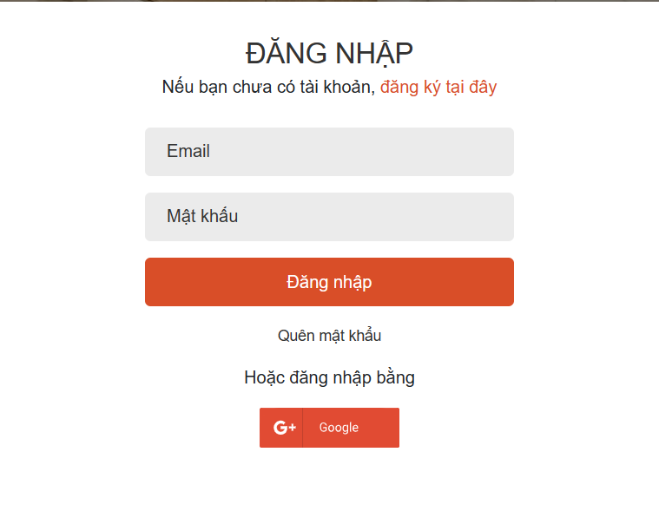

|  |  |  |
| --- | --- | --- |
| **Field Name** | **Field Type** | **Description** |
| Email* | Text Box | This is for user to input valid email address for logging in |
| Password* | Password Box | This is for user to input password for logging in |
| Login | Button | User clicks to authenticate him/herself into the system with provided email & password |
| Register | Button | User clicks to redirect to the User Register page for registering new user account to access the system |
| Forgot Password? | Hyperlink | User clicks to redirect to the Password Reset page for resetting his/her forgot password |
| Login with Google | Hyperlink | Allow user to login with his/her Google account |

##### **Database Access**

|  |  |  |
| --- | --- | --- |
| **Table** | **CRUD** | **Description** |
| User | R | Verify UserName & Password information |
| Setting, User | R | Specify the authorizations of the logged-in user |

***SQL Commands:***

- Check login:

"Select * from user where email = ? and google_id IS NULL"

- Check login by Google:

"Select * from user where email = ? and google_id = ? "

- Login with Google:

"Insert Into user(user_id , email, name, given_name, family_name, picture, google_id, role_id) "

+ "Values(?, ?, ?, ?, ?, ?, ?, ?)"

##### **UI Design**

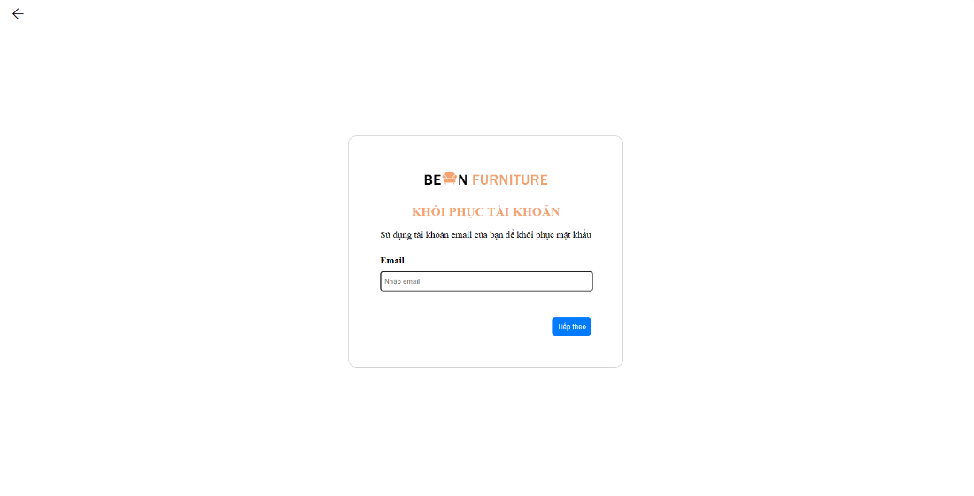

## 3. Register

##### **UI Design**

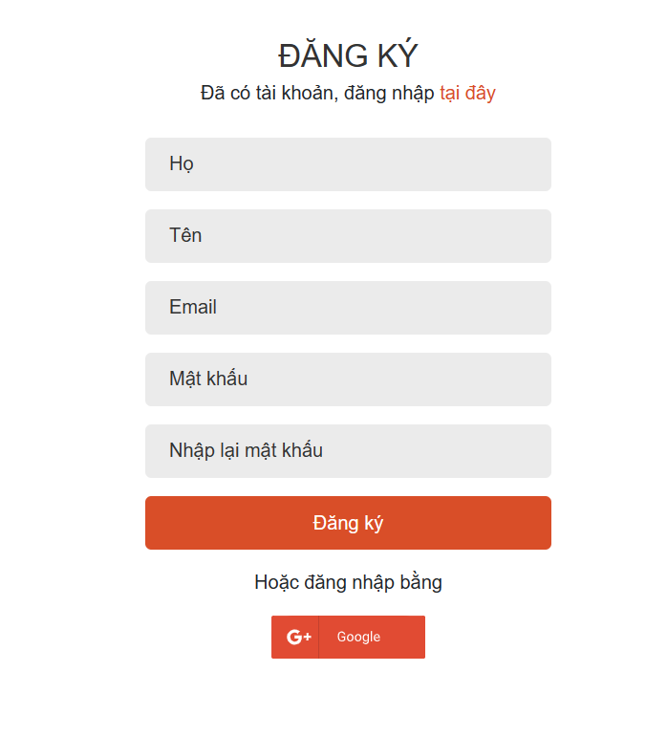

|  |  |  |
| --- | --- | --- |
| **Field Name** | **Field Type** | **Description** |
| First Name* | Text Box | This is for user to enter a valid first name to register |
| Lats Name* | Text Box | This is for user to enter a valid last name to register |
| Email* | Text Box | This is for user to input valid email address for register |
| Password* | Password Box | This is for user to input password for register |
| Re-enter password* | Re-enter password Box | This is for the user to re-enter the entered password to register |
| Register | Button | User clicks to enter Registration to register a new user account to access the system |
| Login | Button | User clicks to redirect to the User Login page for account to access the system |
| Login with Google | Hyperlink | Allow user to register with his/her Google account |

##### **Database Access**

|  |  |  |
| --- | --- | --- |
| **Table** | **CRUD** | **Description** |
| Setting | RU | Query the list of current settings from the database  Update status of a specific setting |

***SQL Commands:***

- Register a new Account:

"Insert Into user(user_id, email, password , name, given_name, family_name, role_id) "

+ "Values(?, ?, ?, ?, ?, ?, ?)"

## 4. Product Management

##### **UI Design**

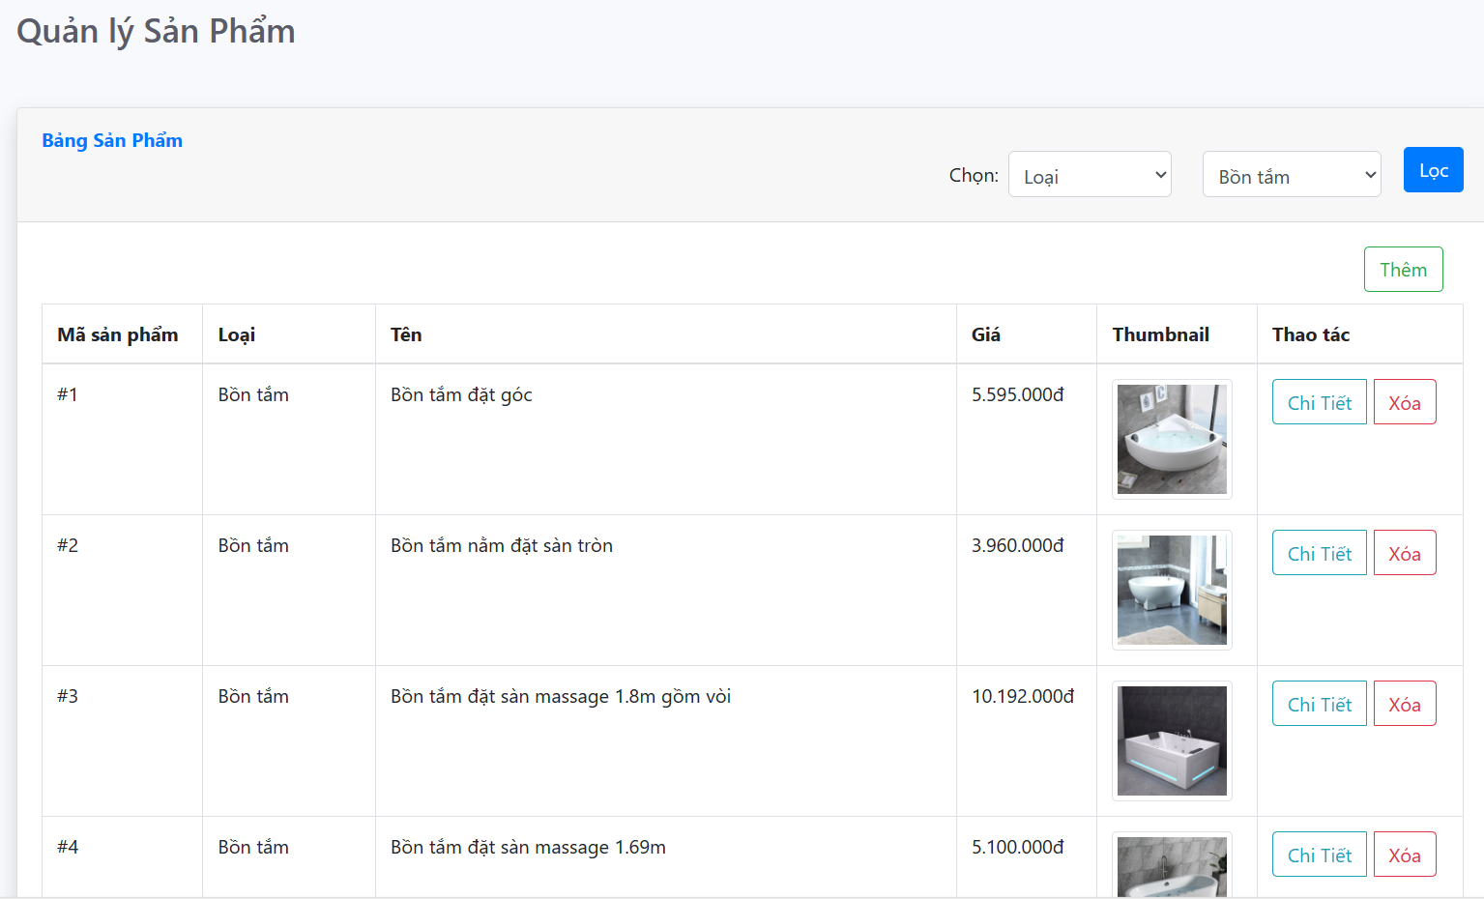

|  |  |  |
| --- | --- | --- |
| **Field Name** | **Field Type** | **Description** |
| ***Search Fields*** | | |
| Search Category | Combo Box  Single-Choice | Filled in the list of product types  Allows you to filter the list by product name or price;  The default value is "product name" |
| Search Status | Combo Box  Single-Choice |  |
| Filter | Button | Click to refresh the list with the defined filter(s). |
| Add New | Hyperlink | Click to open the add product page to add new products (master data) |
| ***Data Table*** | | |
| Product Id | Integer | Auto-increased identifier of the products |
| Category Name | Text | Name of the category |
| Name Product | Text | Name of the products |
| Price | Text | Price of the products |
| Thumbnail | Integer | Images of each product type |
| ***Data Actions*** | | |
| Edit | icon | Click to open the Products Details page for updating all information of products (master data) |
| Delete | icon | Click to delete product in product list (master data) |

***SQL Commands:***

* View products via Category Id:

"SELECT * FROM product WHERE category_id= ?"

* View all products:

"SELECT product.product_id, product.category_id, product.title, product.price, product.quantity, product.discount, product.thumbnail, product.description, product.purchases, product.created_at, category.name AS category_name "

+ "FROM product "

+ "LEFT JOIN category ON product.category_id = category.category_id"

* Find products by name:

"Select * from product "

+ "Where title like ? "

* View products by Id:

"SELECT product.product_id, product.category_id, product.title, product.price, "

+ "product.quantity, product.discount, product.thumbnail, product.description, "

+ "product.purchases, product.created_at, category.name AS category_name "

+ "FROM product "

+ "LEFT JOIN category ON product.category_id = category.category_id "

+ "WHERE product.product_id = ?";

* View products by Category:

"SELECT * FROM product WHERE category_id= ?"

* View the latest products:

"SELECT * FROM product ORDER BY created_at DESC LIMIT 8"

* Count products by Category Id:

"SELECT c.category_id, c.name, COUNT(p.product_id) AS productCount\n"

+ "FROM category c\n"

+ "LEFT JOIN product p ON c.category_id = p.category_id\n"

+ "GROUP BY c.category_id, c.name;"

* View products by Price:

"SELECT * FROM product \n"

+ "WHERE price between ? and ?"

* Delete product via Product id:

"DELETE FROM product WHERE product_id = ?"

* Sort products by name in ascending:

"SELECT * FROM product ORDER BY `title` ASC"

* Sort products by name in descending :

"SELECT * FROM product ORDER BY `title` DESC"

* Sort products by price in ascending:

"SELECT * FROM product ORDER BY `price` ASC"

* Sort products by price in descending:

"SELECT * FROM product ORDER BY `price` DESC"

* Sort products by most recent creation date:

"SELECT * FROM product ORDER BY `created_at` DESC"

* Sort products by latest creation date:

"SELECT * FROM product ORDER BY `created_at` ASC

## 5. Product Detail

##### **UI Design**

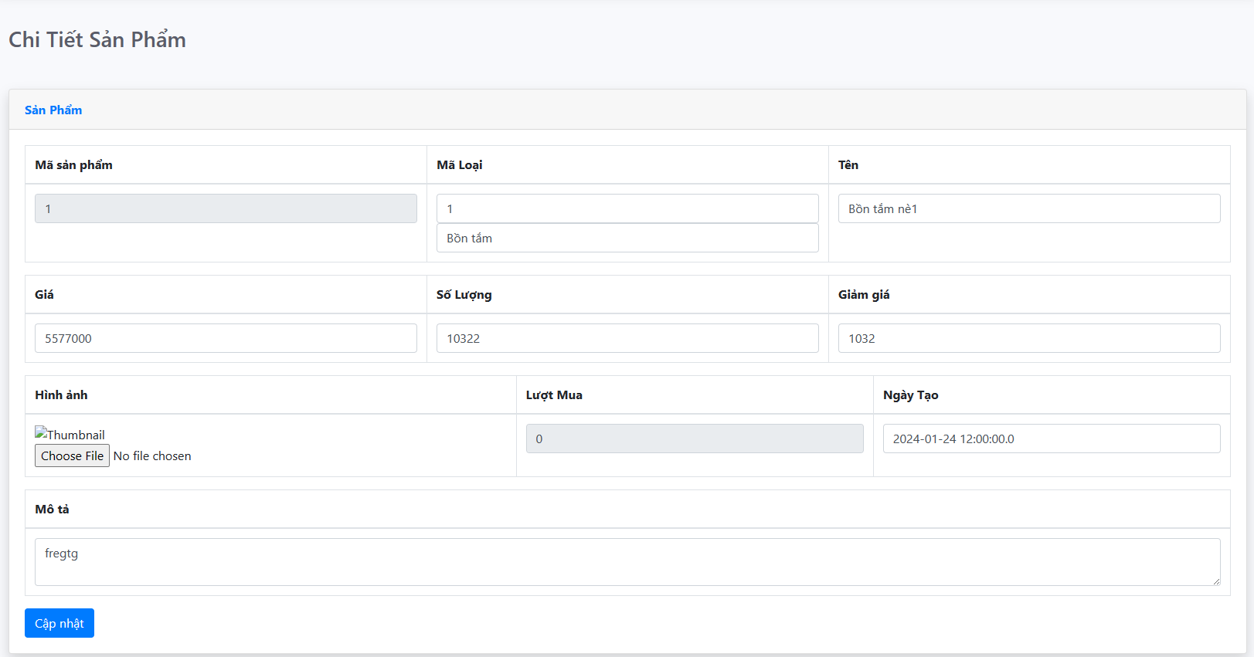

|  |  |  |
| --- | --- | --- |
| **Field Name** | **Field Type** | **Description** |
| Product Id | Text Box  Integer (>0) | Auto-increased identifier of the products |
| Category Name | Text Box  String (50) | Name of the category |
| Name | Text Box  String (20) | Name of the products |
| Price | Text Box  Integer (>=0) | Price of the products |
| Quantity | Text Box  Integer (>=0) | Quantity of the products |
| Discount | Text Box  Integer (>=0) | Discount for each product type in the product list |
| Thumbnail | Button | Click choose file to select the file you want to upload |
| Purchases | Text Box  Integer (>=0) | Shows the number of views after purchasing the products |
| Created At | Text Box  Integer (>=0) | Automatically update the latest date and time when creating products |
| Description | Text Area  String (200) | Description of the products |
| Update | Button | Click to store new or updated products details |

##### **Database Access**

* Product updates:

"UPDATE product "

+ "SET category_id = ?, title = ?, description = ?, quantity = ?, "

+ " thumbnail = ?, discount = ?, purchases = ?, price = ? "

+ "WHERE product_id = ?"

## 6. Add Product

##### **UI Design**

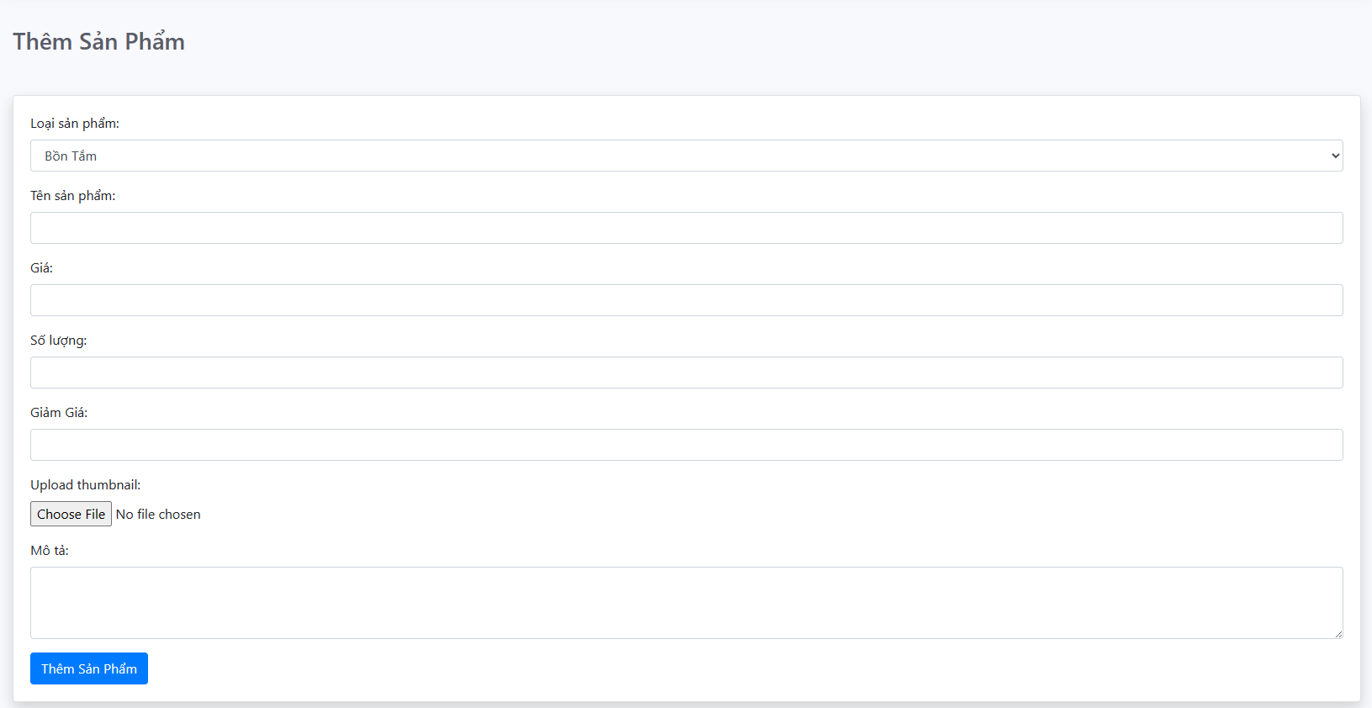

|  |  |  |
| --- | --- | --- |
| **Field Name** | **Field Type** | **Description** |
| Category Name | Text Box  String (20) | Name of the category |
| Name | Text Box  String (20) | Name of the products |
| Price | Text Box  Integer (>=0) | Price of the products |
| Quantity | Text Box  Integer (>=0) | Quantity of the products |
| Discount | Text Box  Integer (>=0) | Discount for each product type in the product list |
| Thumbnail | Button | Click choose file to select the file you want to upload |
| Purchases | Text Box  Integer (>=0) | Shows the number of views after purchasing the products |
| Created At | Text Box  Integer (>=0) | Automatically update the latest date and time when creating products |
| Description | Text Area  String (200) | Description of the products |
| Update | Button | Click to store new or updated products details |

##### **Database Access**

* Add products:

"INSERT INTO product (category_id, title, description, quantity, price, thumbnail, discount) "

+ "VALUES (?, ?, ?, ?, ?, ?, ?)"

## 7. Home

##### **UI Design**

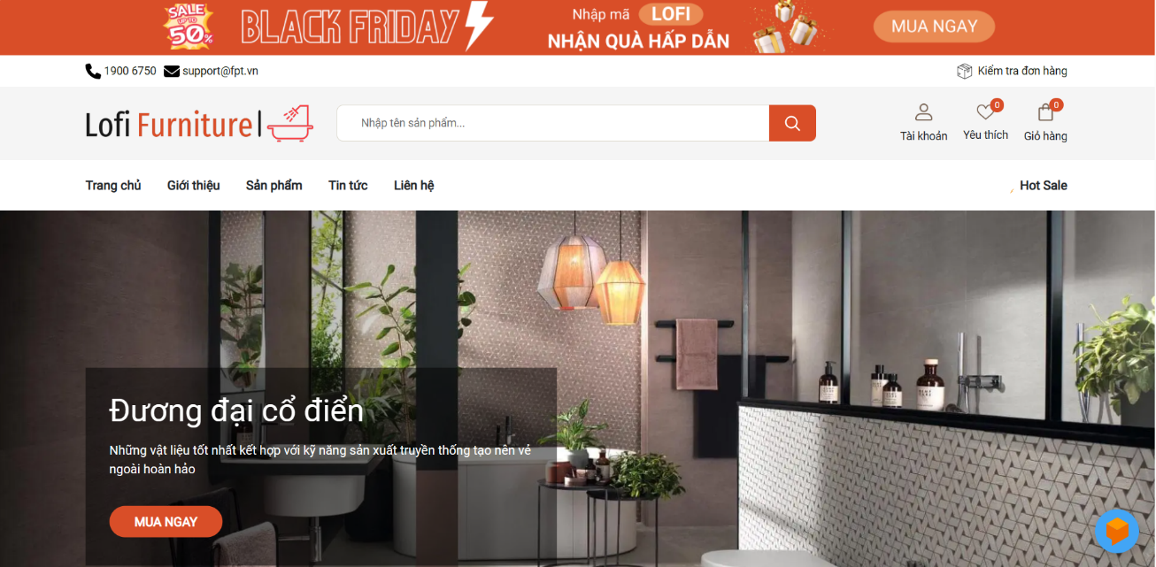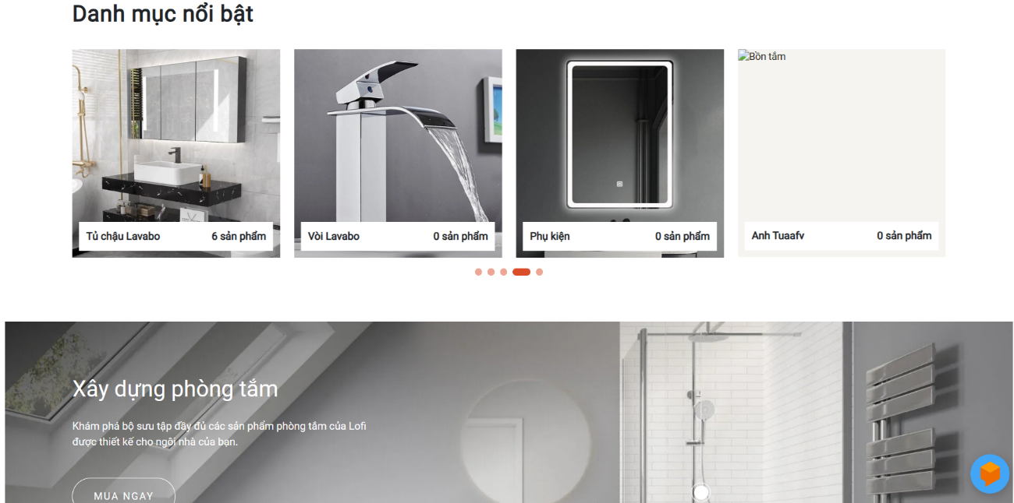

|  |  |  |
| --- | --- | --- |
| **Field Name** | **Field Type** | **Description** |
| ***Header*** | | |
| Logo | Icon | click on the Logo, it will return to the home page by default |
| Search Phase | Text Box  String (30) | Allow to search using the name or map values  Default value: blank |
| Search | Button | Click to refresh the list with the defined filter(s). |
| Account | Button | Click to open the popup to choose to log in or register to access the system |
| Favorites | Icon | Click to open Popup to see products added to favorites |
| Cart | Button | Click to redirect to the cart page to check your cart in the system |
| Introduce | Button | Click here to redirect to the system's brand product introduction page |
| Products | Button | Click here to redirect to the product page  Shows all products available on the system |
| News | Button |  |
| Contact | Button | Click here to redirect to the contact page  Shows store information and contacts |
| Check order | Button | Click redirect to page to view all placed orders |
| ***Slider*** | | |
| Slider |  | show category types |
| Featured categories |  | Shows all products in separate categories |
| Box chat | Button | Click to display an automatic AI chat that can advise customers when they ask questions |

##### **Database Access**

## 8. Pay Cart

##### **UI Design**

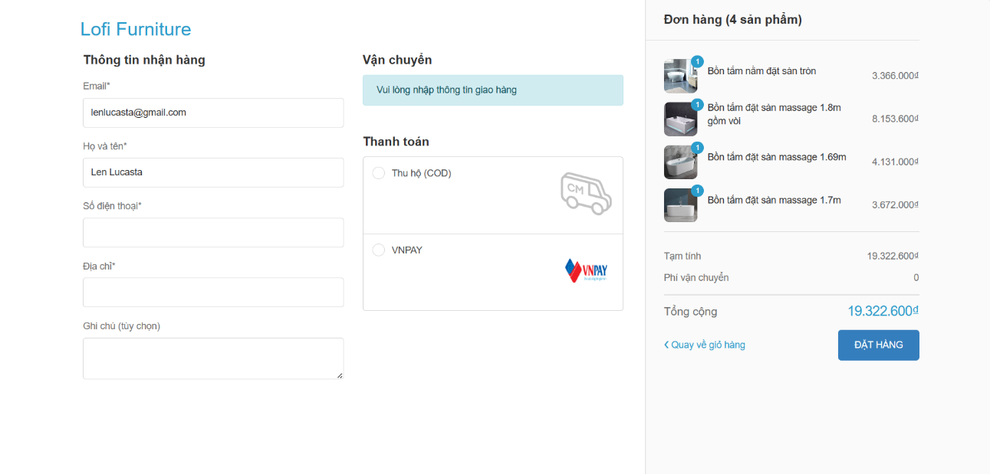

|  |  |  |
| --- | --- | --- |
| **Field Name** | **Field Type** | **Description** |
| ***Information*** | | |
| Email | Text Box  format (@gmail.com | Order's email |
| Full Name | Text Box  String (30) | Full name of the person placing the order |
| Phone number | Text Box  Integer (0-9) | Orderer's phone number |
| Address | Text Box  String (100) | address of the orderer |
| Notes | Text Box  String (200) | Note the details of the orderer's request |
| ***Data Pay*** | | |
| COD | Click | Click here if you want to pay in cash |
| VNPAY | Click | Click here if you want to pay by bank card |
| ***View Order*** | | |
| Products | icon | Click to open the Products Details page for updating all information of products (master data) |
| Ship | Ion | Click to delete product in product list (master data) |
| Total |  |  |
| Return to cart |  |  |
| Order | Button | Click here to redirect to the payment steps detail page |

##### **Database Access**

## 9. Pay

##### **UI Design**

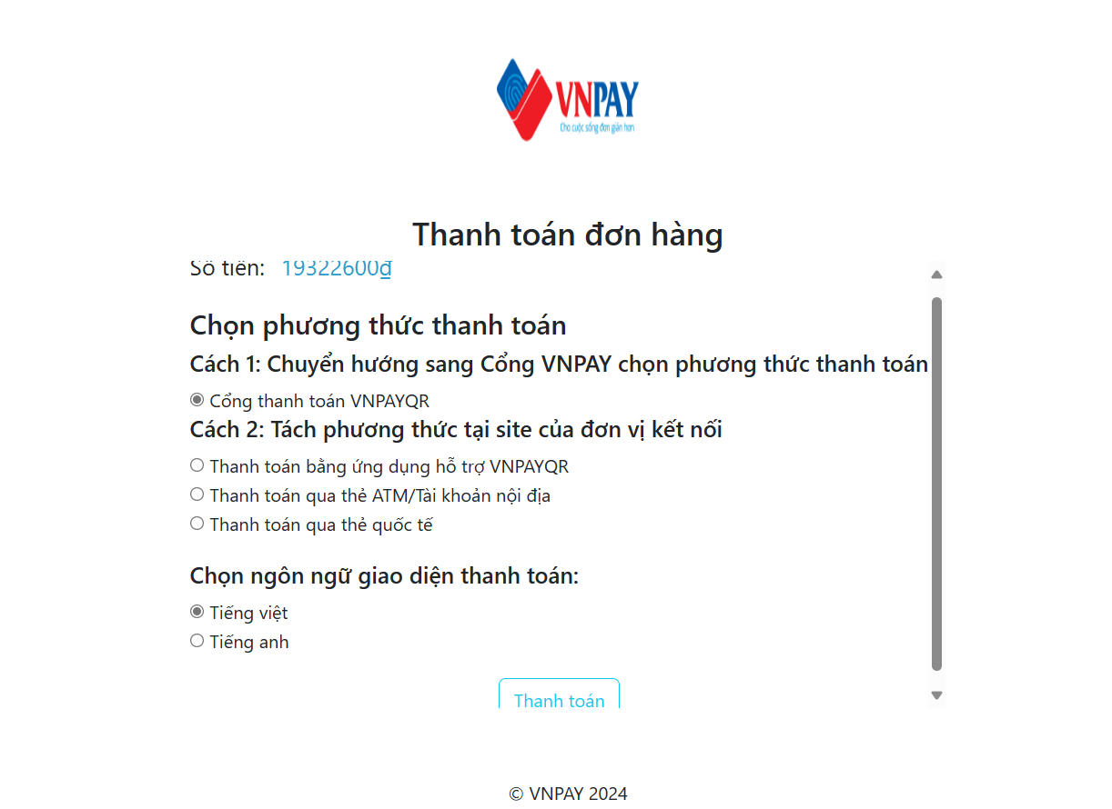

|  |  |  |
| --- | --- | --- |
| **Field Name** | **Field Type** | **Description** |
| ***Select a payment method*** | | |
| VNPAY payment gateway | Click | Click select payment method |
| methods using VNPAY | Click | Click on the box to select the appropriate payment   * Pay by QR * Payment via ATM card/domestic account * international card payment |
| payment language | Click | Select the appropriate language:   * Vietnamese * English |
| Pays | Button | Click redirect to order payment method selection page |

##### **Database Access**

## 10. Choose Pay

##### **UI Design**

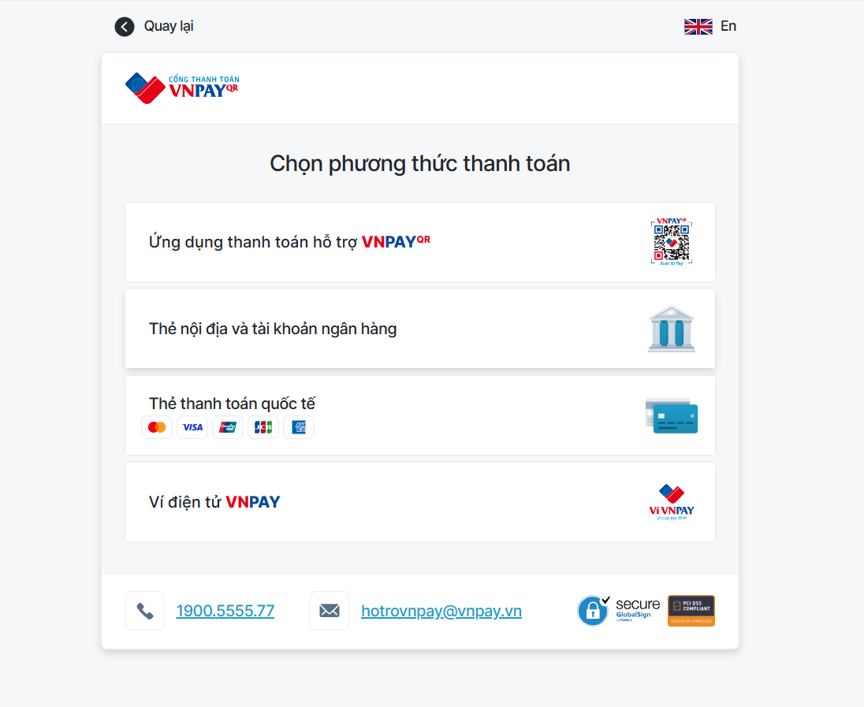

|  |  |  |
| --- | --- | --- |
| **Field Name** | **Field Type** | **Description** |
| ***Select the payment method type*** | | |
| VNPAY payment gateway | Click | Click select payment method |
| methods using VNPAY | Click | Click on the box to select the appropriate payment   * Pay by QR * Payment via ATM card/domestic account * international card payment |
| payment language | Click | Select the appropriate language:   * Vietnamese * English |
| Pays | Button | Click redirect to order payment method selection page |

##### **Database Access**

## 12. Payment Success

##### **UI Design**

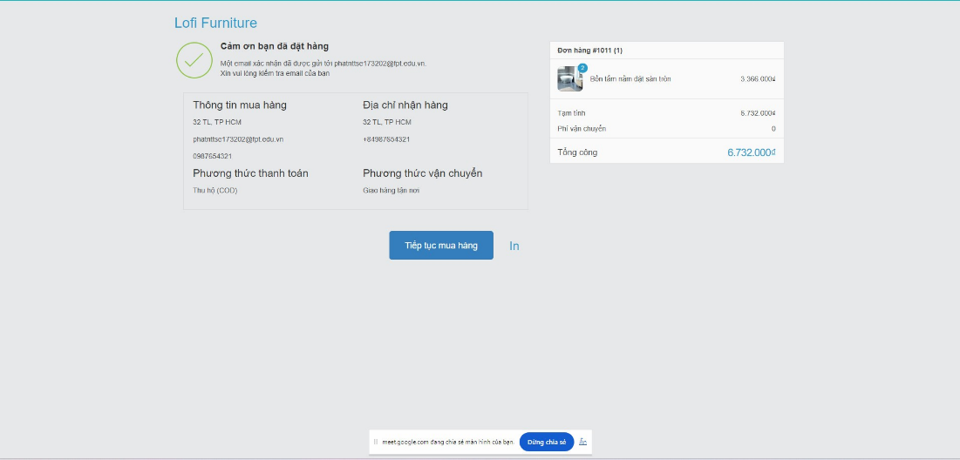

|  |  |  |
| --- | --- | --- |
| **Field Name** | **Field Type** | **Description** |
| ***Information*** | | |
| Continue shopping | Button | Clicking here will redirect to the home page to continue shopping |
| Print | Button | When clicked, the invoice and order information will be printed |

##### **Database Access**

## 13. Order Management

##### **UI Design**

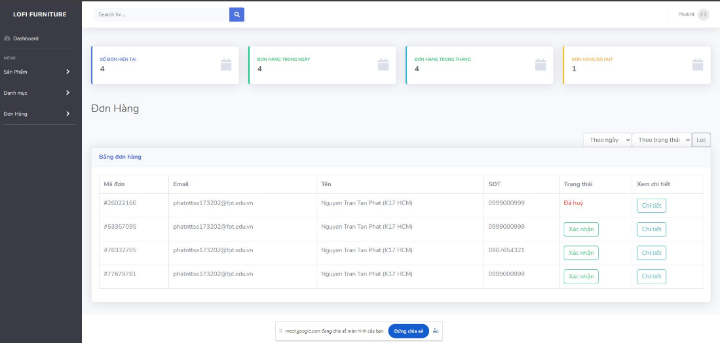

|  |  |  |
| --- | --- | --- |
| **Field Name** | **Field Type** | **Description** |
| ***Information*** | | |
| Current order number | Integer | Auto-increased identifier of the orders |
| Orders during the week | Integer | Auto-increased identifier of the orders |
| Orders during the month | Integer | Auto-increased identifier of the orders |
| Order has been cancelled | Hyperlink | Click to open the add product page to add new products (master data) |
| ***Search Field*** | | |
| Search Category | Combo Box  Single-Choice | Filled in the list of product types  Allows you to filter the list by product name or price;  The default value is "product name" |
| Search Status | Combo Box  Single-Choice |  |
| Filter | Button | Click to refresh the list with the defined filter(s). |
| ***Data Table*** |  |  |
| Order Id | Integer | Auto-increased identifier of the products |
| Email | Text | Customer email |
| Name | Text | Customer name |
| Phone number | Integer | Phone number of Customer |
| ***Data Actions*** | | |
| Confirm | Button | confirm the customer's order |
| Detail | Button | Click to open the Orders Details page for updating all information of products (master data) |

## 14. Order detail

##### **UI Design**

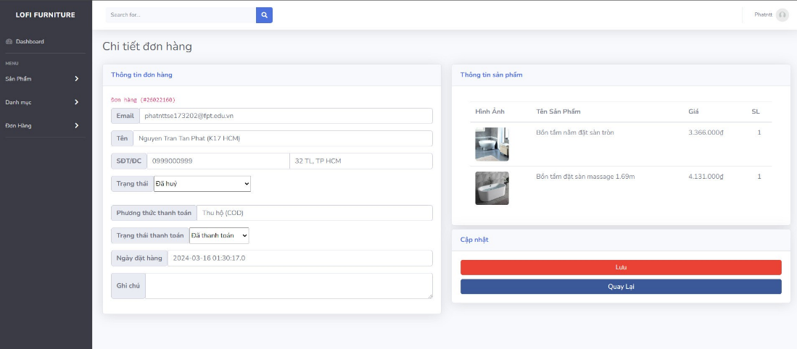

|  |  |  |
| --- | --- | --- |
| **Field Name** | **Field Type** | **Description** |
| Email | Text | Email of customer |
| Name | Text | Name of the customer |
| Phone number | Text Box  Integer | Phone number of customers |
| Address | Text Box  String (50) | Address of customer |
| Status | Combo Box  Single-Choice | Status of order |
| Payment method | Text box | Payment method depends on the customer's choice |
| Payment status | Combo Box  Single-Choice | Payment status of the order |
| Booking date | Text Box  Integer (>=0) | Automatically update the latest date and time when creating order |
| Notes | Text Area  String (200) | Customer order notes |
| Save | Button | Click to store new or updated order details |
| Come back | Button | Click to return to the orders page |

## 15. Cancel order

##### **UI Design**

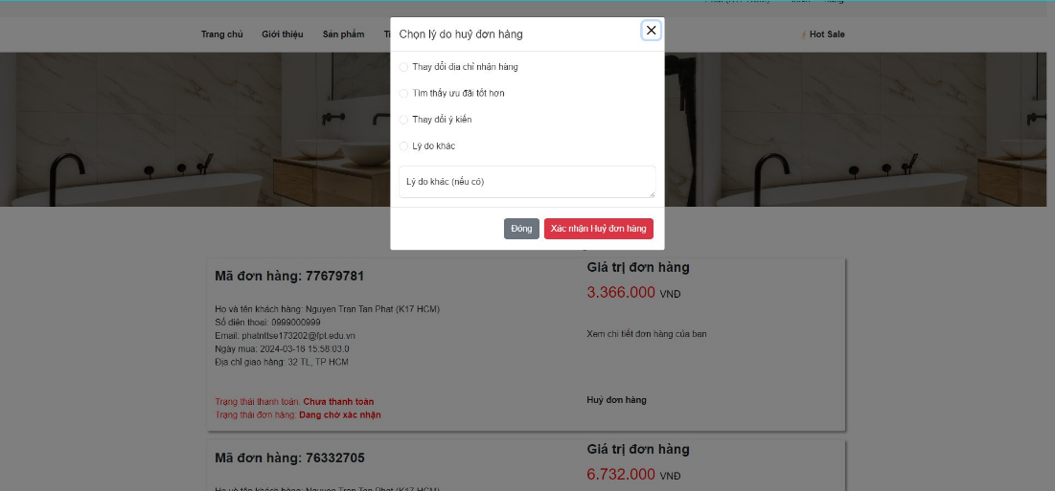

|  |  |  |
| --- | --- | --- |
| **Field Name** | **Field Type** | **Description** |
| Reason cancel order | Click | Select the appropriate reason to cancel the order |
| Other reason | Text Area  String (200) |  |
| Close | Button | Click will close the shows message and return to the order view page |
| Confirm cancel order | Button | When you click to confirm cancellation, the system will notify you that the order was successfully canceled |

## 16. Request cancel order

##### **UI Design**

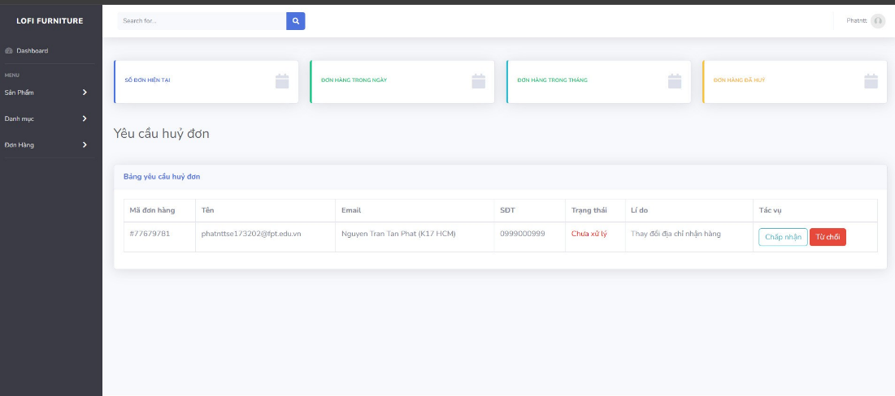

|  |  |  |
| --- | --- | --- |
| **Field Name** | **Field Type** | **Description** |
| ***Data Table*** | | |
| Order Id | Integer | Auto-increased identifier of the products |
| Email | Text | Customer email |
| Name | Text | Customer name |
| Phone number | Integer | Phone number of Customer |
| Reason | Text | Reason cancel order |
| Status | Text | Request status cancel order |
| ***Data Actions*** | | |
| Slider |  | show category types |
| Confirm | Button | Confirm cancel the customer's order |
| Refuse | Button | Refuse requests cancel the customer's order |

# IV. Appendix

## 1. Assumptions & Dependencies

<<Sample:

AS-1: The system assumes stable internet connectivity for users to access the platform.

AS-2: The development team assumes access to development tools and environments required for software development, testing, and deployment.

AS-3: Documentation will be recorded and provided to ensure effective use of the system upon implementation.

AS-4: Personnel and Resources: Assumes that sufficient personnel and resources are available for deployment, development, and maintenance of the system, including technical experts, developers, and project managers.

AS-5: Input Data: Assumes that input data from external systems or users will be provided in a complete, accurate, and appropriate format for processing.

AS-6: Compliance with Regulations: Assumes that the project will comply with all legal regulations, provisions, and internal policies, including privacy and data security regulations.

AS-7: Stability of Environment: Assumes that the deployment environment will be stable and free from major disruptions, but also requires a plan to handle issues if they occur.

AS-8: User Interaction: Assumes that the system's user interface will be designed to be user-friendly and understandable, but also requires providing guidance and support to users as needed.

DE-1: Any changes in business processes or policies that impact system functionality will be communicated in a timely manner to ensure alignment.

DE-2: The successful deployment and adoption of the system may depend on user acceptance testing and feedback for iterative improvements.

DE-3: Collaboration with stakeholders, including domain experts and end-users, is crucial for gathering requirements, validating system functionality, and ensuring alignment with business objectives.

>>

## 2. Limitations & Exclusions

* Our system doesn't work without an internet connection, so it won't function in offline situations.
* We won't be customizing the look of the system too much beyond basic changes like colors and logos.
* Older web browsers or operating systems might not fully support our system.
* We can't fix problems with your computer or phone, like slow performance or compatibility issues.
* Integrating with other services or software not part of our plan might be difficult and require extra time and effort.
* Once the project is done, ongoing support might need separate agreements or extra fees.
* Sometimes, things like slow internet or server issues might slow down our system's performance.
* During maintenance or updates, the system might not work as usual, causing delays or disruptions.

## 3. Business Rules

<<Sample

|  |  |  |
| --- | --- | --- |
| **ID** | **Business Rule** | **Business Rule Description** |
| BR1 | View Wish List | Users can only view their own wish list, not the wish lists of other users.  The wish list should display products in the order they were added. |
| BR2 | Add product to wish list | Only logged-in users can add products to the wish list.  Each product can only be added to the wish list once. |
| BR3 | Add to cart | When the user enters a certain quantity, a message out of stock will be displayed if there is no more stock in stock.  Require users to select sizes and colors before adding |
| BR4 | View cart | Users must log in to view the shopping cart.  Show a message if there are no products in the cart |
| BR5 | Create Order | Confirm valid customer information   Choose from a variety of payment methods and shipping units |
| BR6 | Check out | Make sure your order has been confirmed before proceeding to payment  Calculate shipping costs and other taxes incurred for the order.  Apply discounts or offers customers may have, like discount codes or promotions. |
| BR7 | Check Order | The order must exist in the system   The system needs to confirm the status of the order, including order, processing, shipping, and fulfillment status. |
| BR8 | Request to cancel order | Specify a deadline for order cancellations, including the maximum time between when the order is placed and when cancellation can be requested.  Determine the specific method and process that customers need to follow to request order cancellation |
| BR9 | Login | Users need to enter correct login details like username and password to get into the system.  Only people with permission can access certain parts of the system, matching their roles. |
| BR10 | Login by google | The system ensures that only users with valid Google accounts and appropriate permissions can log in and access certain features or data. |
| BR11 | View Profile | Users must be logged in and authenticated to view their own profile or other users' profiles. |
| BR12 | Edit Profile | When editing a profile, the system should validate the data entered by the user to ensure it meets specified criteria (e.g., format, length, data type).  Changes made to profiles should be logged for auditing purposes. |
| BR13 | Logout | Upon logout, the system should clear any session data associated with the user, including session tokens, cookies, and cached information.  Systems may require users to confirm their intention to log out to prevent accidental logouts. |
|  | Ae bổ sung phần mình vào nhé |  |

## 4. ..